10-1 Exploring Quadratic Graphs
I can graph quadratic functions
Vocab
VoV

Quadratic Function: _____________________________________________________

Standard Form of a Quadratic Function_______________________________________

Parabola_______________________________________________________________

Axis of Symmetry_______________________________________________________

Vertex_______________________________________________________________

Minimum______________________________________________________________

Maximum______________________________________________________________
Identify the vertex of each graph. Tell whether it’s a minimum or a maximum. | Identify the vertex of each graph. Tell whether it’s a minimum or a maximum.
Identify the vertex of each graph. Tell whether it’s a minimum or a maximum. | Identify the vertex of each graph. Tell whether it’s a minimum or a maximum.
Make a table of values and graph: y = x²  Label the axis of symmetry and vertex. | 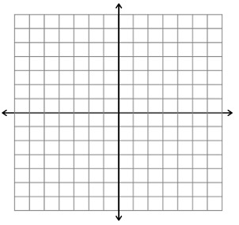
Make a table of values and graph: y = 2x²
Label the axis of symmetry and vertex.

Make a table of values and graph: y = 1/2x²
Label the axis of symmetry and vertex.

Make a table of values and graph: y = 2x² – 2
Label the axis of symmetry and vertex.

Make a table of values and graph: y = –3x²
Label the axis of symmetry and vertex.

Make a table of values and graph: y = –x²
Label the axis of symmetry and vertex.

Make a table of values and graph: y = x² – 3
Label the axis of symmetry and vertex.

Make a table of values and graph: y = x² – 4
Label the axis of symmetry and vertex.

Make a table of values and graph: y = 2x² + 3
Label the axis of symmetry and vertex.

Order each group of Quadratic Functions from widest to narrowest graph.  y = x², y = 5x², y = 3x² | Order each group of Quadratic Functions from widest to narrowest graph.  y = –8x², y = x², y = –x²
Order each group of Quadratic Functions from widest to narrowest graph.  y = –x², y = x², y = –3x² | Order each group of Quadratic Functions from widest to narrowest graph.  y = 6x², y = –7x², y = 4x²

- What is the shape of a quadratic graph?

- What is standard form of a quadratic function?

- Give an example of a quadratic function.

- How does the “a” value affect a quadratic graph?

- How does the “c” value affect a quadratic graph?

