10-1 Exploring Quadratic Graphs
I can graph Quadratic Functions.
Moe sees an eagle flying over the Grand Canyon. Moe estimates that the eagle is 30 feet above the canyon’s edge when the eagle drops a bunny from its claws. The force of gravity causes the bunny to fall toward the ground. The function h = -16t² + 30 gives the height h of the bunny, in feet, after t seconds. Graph this function. | 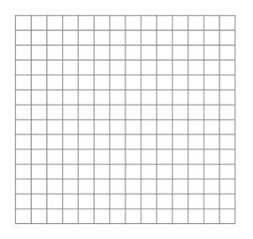
Hussein is sitting in math class staring out the window. He notices a squirrel in a tree about 24 feet above the ground. The squirrel drops an acorn. The function h = -16t² + 24 gives the height h of the acorn after t seconds. Graph this function.

Hailey is walking across a bridge on his way to the mall. She accidently drops her wallet over the edge. Hailey estimates that she is 40 feet above the water. The function h = -16t² + 40 gives her wallet’s approximate height h, in feet, after t seconds, above the water below. In how many seconds will her wallet hit the water?

Jowana and Joanna are riding in a hot air balloon. They drop an apple from the balloon. They ask the hot air balloon operator how high they are, and he says they are 154 feet above the ground. The height h, in feet, of the apple above ground is modeled by the function h = -16t² +154 where t is time in seconds. How long did it take the apple to hit the ground?

Mrs. Bridges drops and egg off the roof of DHS. She drops the egg 72 feet. The height h, in feet, of the egg above ground is given by the function h = -16t² + 72, where t is time in seconds. Graph the function.

Page 514-516, problem numbers 20, 38, 44, 45, 53

