6-5 Parallel & Perpendicular Lines

I can determine whether lines are parallel and write equations of parallel lines in point-slope form and slope intercept form.

Parallel lines never______________

Parallel lines have the ________________ slope and ___________________ y –intercepts

Graph the following equations on your graphing calculator. Answer the following questions. Draw a sketch the graph.
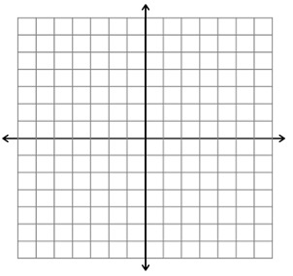
Y = 2x + 3
Y = 2x – 3

Are the lines parallel? ______

Are the slopes of the lines the same? _______

Are the y-intercepts the same? ________

Graph the following equations on your graphing calculator. Answer the following questions. Draw a sketch the graph.
Y = -x + 3
Y = x – 3

Are the lines parallel? ______

Are the slopes of the lines the same? _______

Are the y-intercepts the same? ________

Graph the following equations on your graphing calculator. Answer the following questions. Draw a sketch the graph.
Y = -x + 5
Y = -x – 2

Are the lines parallel? ______

Are the slopes of the lines the same? _______

Are the y-intercepts the same? ________

Find the slope of a line parallel to the graph of the equation  y = 3x + 5 | Find the slope of a line parallel to the graph of the equation  y = x + 4
Find the slope of a line parallel to the graph of the equation  -x + 4y = 8 | Find the slope of a line parallel to the graph of the equation  y - 9 = 0
Are the graphs of the lines in each pair parallel? Explain.  y = 4x +12  y = 4x – 1 | Are the graphs of the lines in each pair parallel? Explain.  y = 4x + 10  -4x +3y = 21
Are the graphs of the lines in each pair parallel? Explain.  y = 3x +10  y = -3x | Are the graphs of the lines in each pair parallel? Explain.  y = -1/2x + 7  y = -1/2x - 7

Write an equation for the line that is parallel to the line and passes through the given point.  (3, 4); y = 2x – 7  Point-slope form:  Slope intercept form: | Write an equation for the line that is parallel to the line and passes through the given point.  (1, 3); y = -4x + 5  Point-slope form:  Slope intercept form:
Write an equation for the line that is parallel to the line and passes through the given point.  (4, -1); y = x - 3  Point-slope form:  Slope intercept form: | Write an equation for the line that is parallel to the line and passes through the given point.  (4,0); y= 2x+9  Point-slope form:  Slope intercept form:

How can you tell if two lines are parallel without graphing them?

