6-4 Point slope form of a linear equation

I can graph and write linear equations in point slope form.

Point slope form:

Slope Intercept form:

Standard Form:

Writing Equations in Point Slope Form
Write an equation of a line with slope -3 and passes through the point (-1,7)

Write an equation of a line with slope 5 and passes through the point (-2,-5)

Write an equation of a line with slope 1/2 and passes through the point (10,-8)

Graph the equation y-5 = ½( x-2)
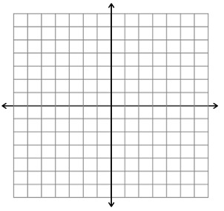

Graph the equation y + 2 = -3/2( x + 3)
Graph the equation y-1 = -( x + 3)
Graph the equation y-4 = -2( x- 2)

Is the relationship shown by the data linear? If it is, model the data with an equation.

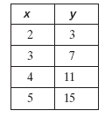

Is the relationship shown by the data linear? If it is, model the data with an equation.
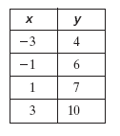

Is the relationship shown by the data linear? If it is, model the data with an equation.
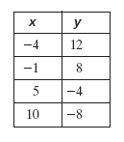

Is the relationship shown by the data linear? If it is, model the data with an equation.
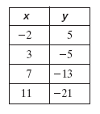

Write an equation of each line in point-slope form.

Write an equation of each line in point-slope form.

Write an equation of each line in point-slope form.

A line passes through the given points. Write an equation in point slope form. Then write the equation in slope intercept form.

(5, 7), (6, 8)
A line passes through the given points. Write an equation in point slope form. Then write the equation in slope intercept form.

(1, 2), (3, 8)
A line passes through the given points. Write an equation in point slope form. Then write the equation in slope intercept form.

(4, 2), (–4, –2)
A line passes through the given points. Write an equation in point slope form. Then write the equation in slope intercept form.

(8, –2), (14, 1)
A line passes through the given points. Write an equation in point slope form. Then write the equation in slope intercept form.

(–3, 4), (1, 6)

