6-3 Standard Form of a Linear Equation

Standard Form

Graphing Horizontal and Vertical Lines
Graph y = 3
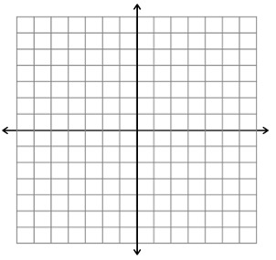
Graph x = 3
Graph y = -4

Graph x = -2
For each equation tell whether its graph is a horizontal or vertical line.

- x = 2

- y = -1/2

- y = 8

- x = -5
The ninth grade class holds a car wash to raise money to send Mrs. Talley to try out for The Voice. A wash costs $4 per car and $5 per truck. Write an equation in standard form to relate the number of cars and trucks the students must wash to raise $1000.00

Hassan runs at an average rate of 6 miles per hour. He walks at a rate of 3 miles per hour. Write an equation in standard form to relate the times he could spend walking and running to travel a distance of 18 miles.

1. What does slope mean?

2. What is the formula for slope?

3. What is standard form of a linear equation?

4. What is slope intercept form of a linear equation?

5. What does an equation of a vertical line look like?

6. What does an equation of a horizontal line look like?

7. What is the slope of a horizontal line?

8. What is the slope of a vertical line?

Complete page 301-302 problems 10-12, 19-26, 36, 37, 38-40, 47, 48
And page 303 problems 6-10 (at the bottom of the page)

