6-3 Standard Form of a Linear Equation

Slope intercept form of a linear equation:

Standard Form:

Y-intercept

X-intercept

Find the x –intercept | Find the x-intercept

When an equation is in standard for we can graph it by solving for the x and y intercepts.

Follow these steps to find x and y intercepts for equations in Standard form:

To find the x intercept: Substitute____ for ____and solve for _____.

To find the y intercept: Substitute____ for ____and solve for _____.

Ok! Let’s find some intercepts. 
Find the x and y intercepts of 5x +2y = -10

Find the x and y intercepts of 3x +5y = 15

Graph x + y = 2 using intercepts
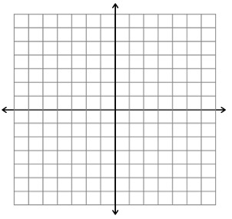
Graph 3x + y = 6 using intercepts

Graph each of the following using intercepts
3x + y = 3
5x - 4y = -20
-7x + 2y = 14

