6-2 Slope intercept form of a linear equation

I can write equations in slope intercept form and graph linear equations.

Slope intercept form:

Linear equation:

y-intercept:

Identify the y- intercept | Identify the y- intercept
Identify the y- intercept | Identify the y- intercept

Find the slope and y-intercept of the equation.  y= -2x +1 | Find the slope and y-intercept of the equation.  y = 7/6x -3/4
Find the slope and y-intercept of the equation.  y = -4/5x | Find the slope and y-intercept of the equation.  y – 2 = 3x
Find the slope and y-intercept of the equation.  2y – 6 = 3x | Find the slope and y-intercept of the equation.  y = 1/2
Find the slope and y-intercept of the equation.  2y + 4 = -6x | Find the slope and y-intercept of the equation.  y – 9x = ½
Write an equation of the line with the given slope and y-intercept.  m= 2/9  b = 3 | Write an equation of the line with the given slope and y-intercept.  m= 3  b = 2/9
Write an equation of the line with the given slope and y-intercept.  m= 5  b = 0 | Write an equation of the line with the given slope and y-intercept.  m= 0  b = 2
Write an equation of the line with the given slope and y-intercept.  m= 1/2  b = .7 | Write an equation of the line with the given slope and y-intercept.  m= 2  b = -6
Write an equation of the line with the given slope and y-intercept.  m= -5  b = -6 | Write an equation of the line with the given slope and y-intercept.  m= .2  b = -.5

Write the equation of the line | Write the equation of the line
Write the equation of the line | Write the equation of the line
Graph y= 3/2x -2  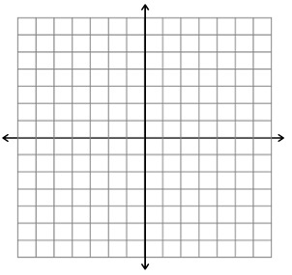 | Graph y= 1/3x +2

Graph y= 1/2x + 4 | Graph y= -5x + 2
Graph y= -x + 2 | Graph y= -5x
Graph y= x | Graph y= 3

