Chapter 5 Test REVIEW
1.
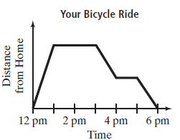
Explain the activity in each section of the graph.

Find the Domain and Range of the relation {(4,3), (-2, 1), (-1,3), (4,-2),
(-1,1)}

Determine whether each relation is a function using a mapping diagram
{(11,-2), (12, -1), (13,-2), (20,7)}

Determine whether the relation
{(3, 7), (3, 5), (3, −2), (3, 4), (3, 1)} is a function using the vertical line test.
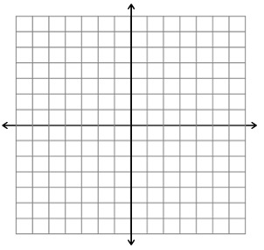
Evaluate f(n)= -3n - 10 for n = 6 | Solution_______________________
Evaluate the function rule f(x) = x - 6 to find the range of the function for the domain {-2,0,5} | Solution_______________________
Model the function f(x) = 3x + 4 with a table of values and a graph

Graph the function f (x) = |x|

Graph the function y = x²

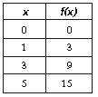  Write a function rule for the table | Solution________________________
To rent a cabin, a resort charges $50 plus $10 per person. Write a function rule to calculate the total cost of renting the cabin. Use your rule to find the total cost for six people to stay in the cabin. | Solution________________________

