5-4
I can write function rules when given a table or a real world situation.

Write a function rule for the table

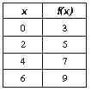

Write a function rule for the table

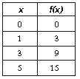

Write a function rule for the table

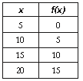

Write a function rule for the table  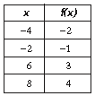 | Write a function rule for the table  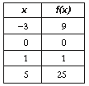

Write a function rule for the table  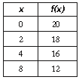 | Write a function rule to calculate the cost of buying bananas at $.39 a pound. How much would it cost to buy 3.5 pounds of bananas?
To rent a cabin, a resort charges $50 plus $10 per person. Write a function rule to calculate the total cost of renting  the cabin. Use your rule to find the total cost for six people to stay in the cabin. | Pens are shipped to the office supply store in boxes of 12 each. Write a function rule to calculate the total number of pens when you know the number of boxes. Calculate the total number of pens in 16 boxes.
Write a function rule to determine the change you would get from a $20 bill when purchasing items that cost $1.25 each. Calculate the change when five of these items are purchased. Can you purchase 17 of these items with a $20 bill? | You invest $209 to buy shirts and then sell them for $9.50 each. Write a function rule to determine your profit. Use your rule to find your profit after selling 24 shirts. How many shirts do you need to sell to get back your investment?

