I can identify functions using a mapping diagram or a vertical line test.
I can evaluate functions.

A function is:

A relation is:

Domain:

Range:

List words that represent the X coordinate | List words that represent the Y coordinate
Find the Domain and Range of the relation {(4,3), (-2, 1), (-1,3), (4,-2), (-1,1)} | Find the Domain and Range of the relation {(5,3), (-4, 10), (-12,5), (4,-6), (11,5)}

Find the Domain and Range of the relation | Determine whether each relation is a function using a mapping diagram  {(11,-2), (12, -1), (13,-2), (20,7)}
  x | y
  5 | 1
  4 | 0
  3 | -1
  2 | -2
Determine whether each relation is a function using a mapping diagram  {(-2,-1), (-1, 0), (6,3), (-2,1)} | Determine whether each relation is a function using a mapping diagram  {(3,-2), (8,1), (9,2), (3,3), (-4, 0)}
Determine whether each relation is a function using a mapping diagram  {(6,0), (7,-1), (6,2), (2,6), (5, -1)} | Determine whether the relation {(3, 0), (−2, 1), (0, −1), (−3, 2), (3, 2)} is a function using the vertical line test  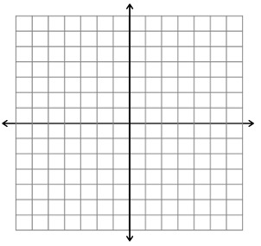
Determine whether the relation {(3, 7), (3, 5), (3, −2), (3, 4), (3, 1)} is a function using the vertical line test. | Determine whether the relation {(6, -7), (5, 6), (1, 4), (4, 5)} is a function using the vertical line test.
What are two ways we can determine whether a relation is a function?

What is a function rule?

What is function notation?

What does evaluate mean?

Evaluate f(n)= -3n - 10 for n = 6 | Evaluate f(x) = -2x + 7 for x = 4

Evaluate f(x) = 2x + 1 for x = 3 | Evaluate f(x) = 5x + 11 for x = -5
Evaluate the function rule f(a) = -3a + 5 to find the range of the function for the domain {-3,1,4}

Evaluate the function rule f(x) = x - 6 to find the range of the function for the domain {-2,0,5}

Evaluate the function rule f(x) = -4x to find the range of the function for the domain {-2,0,5}

