I can interpret, sketch and analyze graphs from situations.

Graph the height of an airplane flying from California to Detroit. | Graph the speed of a person driving to the store and having to stop at one stoplight.
Sketch a graph of the distance from a child’s feet to the ground as the child jumps rope. | Sketch a graph of the altitude of a pelican from take off from shore to diving to water to catch a fish.
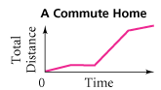  Explain the activity in each section of the graph. | 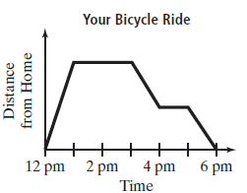  Explain the activity in each section of the graph.
Example 3: Which graph shows you stopped a stop light?  Explain.  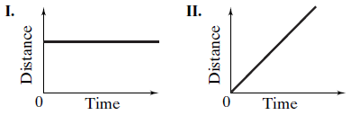 | Explain the activity in each section of the graph.
The graph shows a trip from home to school and back. The trip involves walking and getting a ride from a neighbor. Label each section of the graph.

Suppose you pour water into the container at a steady rate. Which graph shows the change in height of the liquid in the container over time? Explain.

Evaluate f(x) = 2x + 1 for x = 3 | Evaluate f(x) = 5x + 11 for x = -5
Evaluate the function rule f(a) = -3a + 5 to find the range of the function for the domain {-3,1,4}

Evaluate the function rule f(x) = x - 6 to find the range of the function for the domain {-2,0,5}

Evaluate the function rule f(x) = -4x to find the range of the function for the domain {-2,0,5}

