**Motion and Matter Investigation 1 Study Guide**

Use the word bank to complete the sentences.

|  |
| --- |
| attract repel gravity motion force balanced unbalanced magnetic field |

1. When objects are not moving we say the forces are ______balanced____________.

2. _______Gravity_________ is the force that pulls everything down towards the center of the Earth.

3. ___Motion_____________ is the movement of an object.

4. A ____force________ is a push or pull.

5. The stronger the _____magnetic field___________________, the stronger the force.

6. When an object is moving we say the forces are ___unbalanced____________________.

7. When two magnets come together they _____attract_________________.

8. When two magnets push apart they ____repel_________________.

Put an X next to each statement that shows a cause and effect relationship.

__X__ The more magnets you use, the farther the paper clips will move.

____ The average number of paper clips one magnet can pick up is 10.

_X___ When 2 people are pushing on the opposite side of a desk with an equal force, the desk won’t move.

__X__ If you put a magnet on a chair leg, you can suspend a paper clip from it.

____ Sometimes magnets attract and sometimes they repel.

Constructed Response

Explain why a magnet on the bottom of a desk can make a magnet on the top of a desk move.

A magnet on the bottom of a desk can make a magnet on the top of a desk move because the magnets do not have to touch to make things move.

Explain how a paper clip can be suspended in the air using a string and a magnet.

A paper clip can be suspended in the air because the magnet has an invisible force that is pulling the paper clip towards it.

Use the data table to answer the following questions.

Distance the Paper Clip Traveled

|  |  |  |  |
| --- | --- | --- | --- |
| Number of Magnets | Trial 1 | Trial 2 | Trial 3 |
| 1 | 2 cm | 2 cm | 2 cm |
| 2 | 3 cm | 3 cm | 3 cm |
| 3 | 4 cm | 4 cm | 4 cm |

Based on the table, what question could the students be investigating?

____How does the number of magnets affect the distance the paper clips will move?______________

What pattern do you notice in the data table? The pattern I notice is ___As the number of magnets increases by 1, the distance traveled by the paper clip increases by 1 cm.__________________

Predict how many cm the paper clip would travel if we used 4 magnets.

I think the paper clip will move __5____ cm.

Draw a picture of two bar magnets that will attract. Make sure to label each pole as north or south.

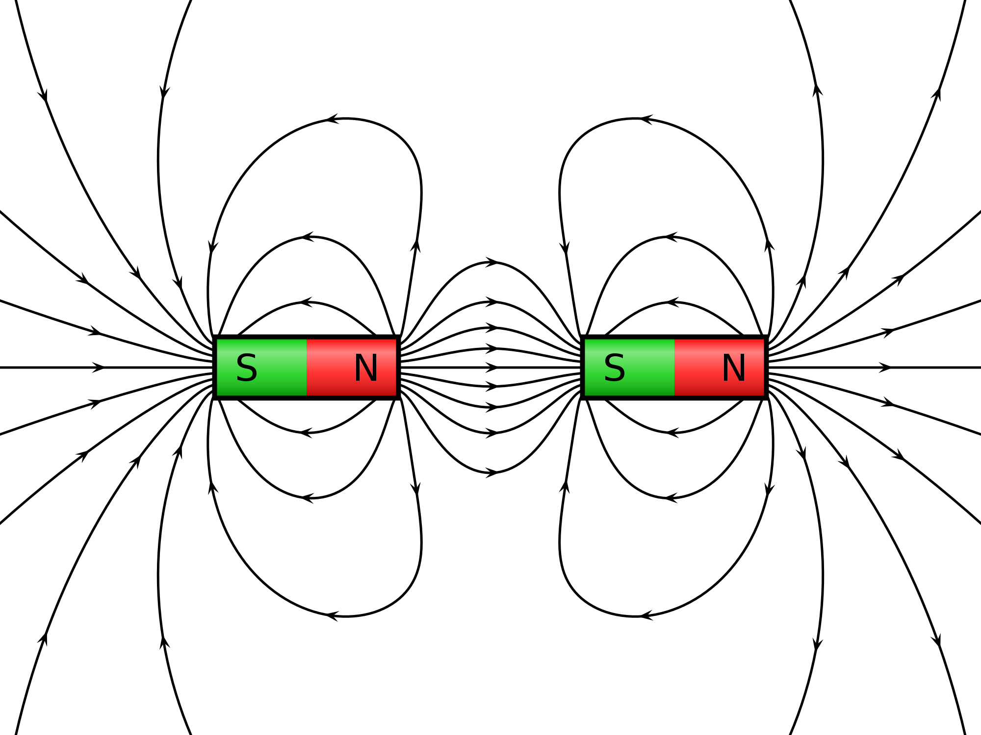

Use your drawing to explain why these magnets will attract.

These magnets will attract because opposite poles are facing each other.

Draw a picture of two bar magnets that will repel. Make sure to label each pole as north or south.

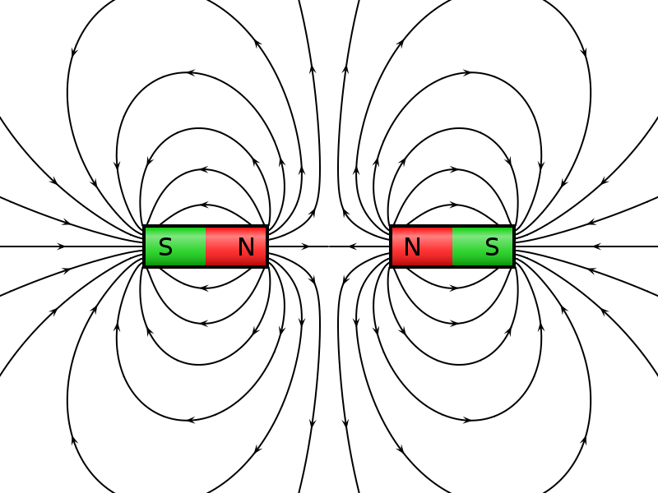

Use your drawing to explain why these magnets will repel.

These magnets will repel because the same poles are facing each other.

None of the rocks in the picture are moving. Draw arrows and label the picture to show all the forces working on the top rock. Write a few sentences to explain how you labeled the picture.

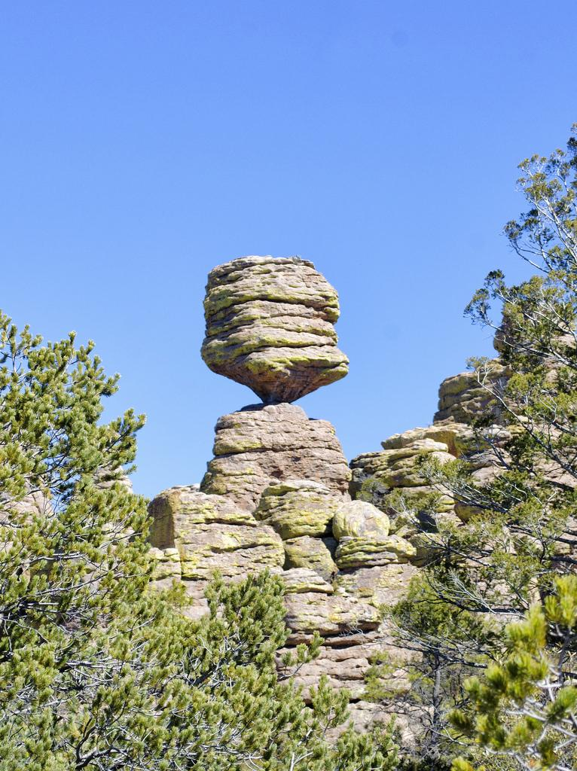

Gravity is pushing down on the top rock, but the bottom rock is pushing back up. Therefore, the forces are balanced and none of the rocks will move.

Student A pushes a cart with a force of 500 units to the right. Student B pushes a cart with a force of 200 units to the left. Which direction will the cart move?

1. It will move to the right.
2. It will move to the left.
3. It will not move.

Explain why you chose your answer.

It will move to the right because the forces are unbalanced. Student A has a stronger force, so the cart will move in the direction student A is pushing.