**Names __________________________________, _____________________________________ Date_______________**

**__________________________________, _____________________________________ Hour_______________**

**Gravity and Orbits**

**Pre-lab**

1. In the picture below, draw how you think Earth moves. Use arrows to indicate direction**.**

**LABEL THE SUN, EARTH AND MOON IN EVERY PICTUER! (you can make a key)**

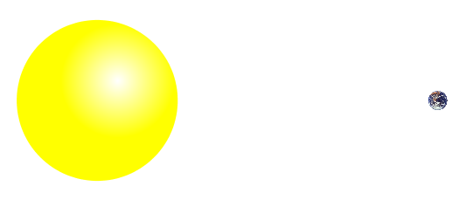

2. Draw a picture using arrows to show what you think the forces might be on the Earth and the Sun.

You can draw a longer arrow to represent a big force, and a shorter arrow to represent a small force.

3. Draw a picture of how you think the Earth would move if these forces were not there. Use arrows to indicate direction.



**Names __________________________________, _____________________________________ Date_______________**

**__________________________________, _____________________________________ Hour_______________**

**Gravity and Orbits**

**Learning Objectives-** Students will be able to:

* Draw motion of planets, Moons and satellites.
* Draw diagrams to show how gravity is the force that controls the motion of our solar system.
* Identify the variables that affect the strength of the gravity.
* Predict how motion would change if gravity was stronger or weaker.

**Part 1: Understanding motion**

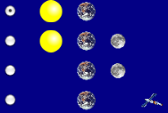

1. Open the ***Gravity and Orbits*** simulation. Take 5 minutes to **explore** how the Earth, Moon, and the Space Station move. Talk about what you find with your partner.
2. Compare the motion of the **Earth moving around the Sun** with the **Moon moving around the Earth**.

If you and your partner each have a computer: Try choosing a different view on each computer for this question.

|  |  |
| --- | --- |
| **Earth moves around the Sun**  Your Picture(use arrows to indicate direction)  Your Description | **Moon moves around the Earth**  Your Picture(use arrows to indicate direction)  Your Description |
| What are some things you find that are the **same** about these motions?  What are some things you find that are **different** about these motions? | |

**Part 2: Understanding Gravity**

1. For the Sun and Earth system:
   1. **Draw** the path of the Earth with **Gravity ON** and **Gravity OFF** (use arrows to indicate direction)

**GRAVITY ON GRAVITY OFF**

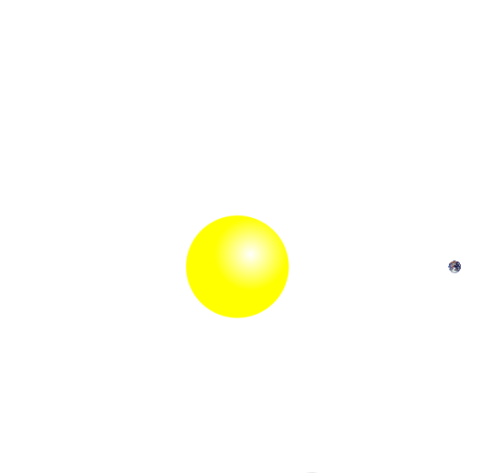

* 1. **Why** do you think gravity is important?

1. **Explore** the simulation to find out how you can change the force of gravity and observe what happens.

**CLASS DISCUSSION:** Share what you found with the class.

1. **Draw** the Sun’s gravitational pull on the Earth **Draw** the Earth’s gravitational pull on the Sun

Use labeled arrows Use labeled arrows

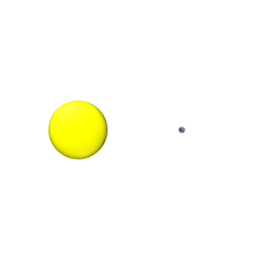

**CLASS DISCUSSION:** Why do you think the Earth moves, but the Sun does not move?

1. Return to your pictures in Questions 2 and add arrows to **show the force of gravity**. Label them with “Gravity Force”.

1. **Play** with the sim to find ways to change the length of the blue gravity force arrows. Collect your results in the table below.

a) Fill in an **ACTION** below and **write** whether or not the gravitational force increases or decreases for both the Sun

and Earth.

|  |  |  |
| --- | --- | --- |
| **ACTION** | **Gravity Force Increases – Sun or Earth** | **Gravity Force Decreases – Sun or Earth** |
| Put star and planet closer together |  |  |
|  |  |  |
|  |  |  |
|  |  |  |
|  |  |  |

b) What can affect the strength of gravitational force? What can you conclude from the results in your table?

1. Comparisons:

a) **Compare** these two cases:

**CASE 1** **CASE 2**

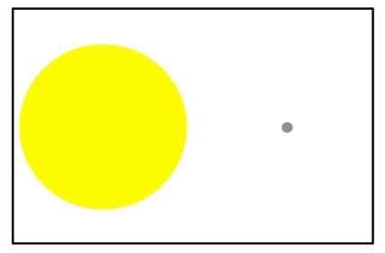 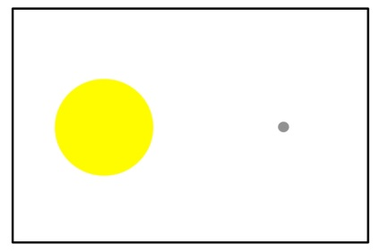

What was changed between Case 1 and Case 2?

**Draw** the force of gravity on the Earth in each case.

b) **Compare** these two cases:

**CASE 1** **CASE 2**

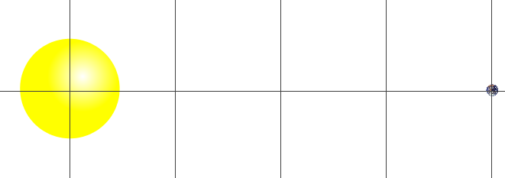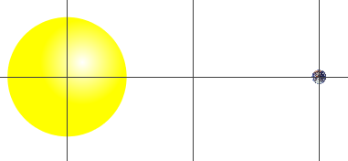

What was changed between Case 1 and Case 2? Explain.

**Draw** the force of gravity on the Earth in each case. Use arrows to indicate direction.

**Part 3: Gravity and Motion**

1. Fill in the table to help describe what you find out.

|  |  |  |  |
| --- | --- | --- | --- |
| **How can you….** | Explain what you changed | Draw the motion paths | What other changes do you notice? |
| **...make the Moon**  **go around the Earth in a bigger circle?** |  |  |  |
| **...make the Earth**  **take more time to go around the Sun?** |  |  |  |
| **...make the Earth**  **take less time to go around the Sun?** |  |  |  |

**Names __________________________________, _____________________________________ Date_______________**

**__________________________________, _____________________________________ Hour_______________**

**Post-Lab**

1. In the picture below, draw how you think the Earth and the Moon move. Use arrows to indicate direction.

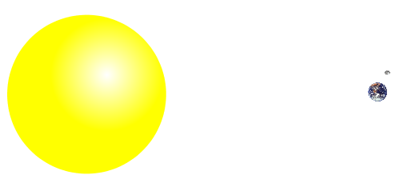

1. On the picture above, show the gravity forces on the Earth, Sun and the Moon. Label with arrows and descriptions.

3. Fill in the following table with your predictions and a drawing of each case. Use arrows to indicate direction.

|  |  |  |
| --- | --- | --- |
| **Predict** what would happen to the gravity force if you… | Gravity **Increases**, **Decreases** or **Stays the Same**? | **Your Drawing**  **And Explanation** |
| ...increase the size of the Star |  |  |
| ...move the star and the planet away from each other |  |  |
| ...decrease the size of the Planet |  |  |
| ...move the Star and Planet closer to each other |  |  |

4. Show in the picture below how you think the Earth and Moon would move if there were no gravity forces at all. Use

arrows to indicate direction.



Explain why you think the Earth and Moon would move in this way.