CLASSROOM RULES:

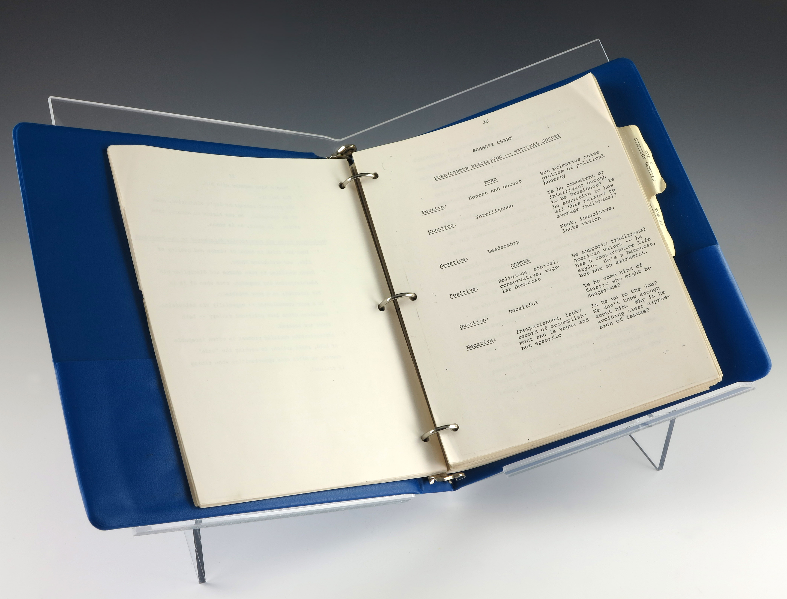

*We use* ***binders****. You are responsible for bringing yours to class every day.*

Binder Tabs: Bellwork, Main Unit, SLOT Unit, Keepers, Assessments



Subscribe to Mr. Suni’s blog to receive email updates!

(Everyone should subscribe! Students, parents, grandparents… everyone!)

<http://iblog.dearbornschools.org/suni/>

**#1 BE ON TIME/PREPARED.**

**#2 BE RESPECTFUL.**

**#3 BE KIND.**

**#4 TELL THE TRUTH.**

**#5 DON’T GIVE UP.**

**Recommended Supply List:**

* **Binder (with paper)**
* **PENCILS**
* **Planner**
* Colored Pencils/Pens
* Glue Stick
* Basic Calculator
* scissors

We will be using the Common Core Standards to guide our learning this school year. They can be found here: [**http://www.corestandards.org/Math**](http://www.corestandards.org/Math) (scroll down to grade 7.) These will help us prepare for the MSTEP and other assessments.



**Grades:** 

**Summative Grades (80% of grade)**

* **Tests**
* **Quizzes** (shorter w/ retakes available)

**Formative Grades (20% of grade)**

* **Homework**: given ***about***  2-3 times a week.  It will usually be about 20 minutes of work.  It is **sometimes** checked the next day.  It is due the moment you walk in the door the next day.  Any work turned in late (correctly done) will receive a score of 70%.
* **Binder:** Show your work. Use **pencil for math problems**. Keep everything in order.
* **Classwork:** *Sometimes* collected and checked.
* **Class Participation:** You will be given an “A” for this part of your grade if you  1. work well in our  small groups, 2. give your best effort in class and on your homework, 3. Follow the procedures that you are expected to follow in class.

**BRYANT 7th grade Math**

**Mr. Suni…………… sunip@dearbornschools.org**

CLASSROOM GUIDE