**A.O.W. #4: Due by Thursday this week! Name: Hr.**

1. Chunk the article into manageable (2 paragraphs max.) pieces. **Number them. Don’t forget the title/opening!**
2. Highlight at least three words you are not familiar with or that are important and define them on the graphic organizer.
3. Show evidence of a close reading. Mark up the **left side** of the text (**each chunk)** with questions and/or comments that demonstrate interacting with the text. You may also include any confusion you have.
4. Complete the attached graphic organizer to analyze author’s craft

# **Ron Stallworth, the Inspiration for 'BlacKkKlansman,' Chronicles Experience Within the KKK**

By: Caitlin Yamada Jan 24, 2019

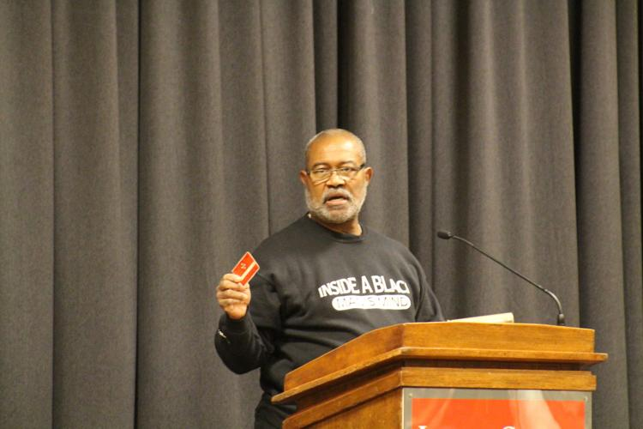

Ron Stallworth speaks Jan. 24 at the Memorial Union about his story of being a black detective who infiltrated the Ku Klux Klan. "...And about 90 days later I got my membership card. Certifying me as a member of the knights of the Ku Klux Klan under David Duke's operation for the year 1979."

“You came to hear how a crazy black guy took on the KKK and made a fool of the grand wizard David Duke,” said Ron Stallworth, the black detective who infiltrated the Colorado Springs Ku Klux Klan in 1978. On Thursday, to a packed crowd in the Sun Room of the Memorial Union, Stallworth told the story of his investigation that inspired his book “Black Klansman: A memoir” and the recent movie “BlacKkKlansman,” which is nominated for four Golden Globe Awards and six Oscars this year.

In October of 1978, Stallworth was sitting in his office as a detective in the intelligence division and was reading the newspaper to see what was happening and what could impact the city. “On this particular day, I saw an ad in the classified section,” Stallworth said. “It said simply ‘Ku Klux Klan, for information’ and then there was a PO box.” Stallworth decided to write a note stating he, “hated ... anybody else who isn't pure Aryan white like I am.”

Stallworth said he made a mistake when signing the letter. Instead of putting his undercover name, Stallworth signed his real name. A week later he received a phone call on the untraceable undercover line asking for him. The voice on the other side of the line said they were Ken O’Dell, the organizer of the Colorado Springs KKK. “He said ‘I got your note, you had some interesting things to say, why do you want to join,’” Stallworth said. He continued the facade and O’Dell responded that Stallworth was just the kind of guy they were looking for and asked when they could meet. “And that, ladies and gentlemen, was the beginning of my investigation,” Stallworth said.

The investigation, which involved using an undercover narcotics officer and an in-person stand-in, lasted for seven-and-a-half months. During this time, Stallworth identified many KKK members who were military personal, two of whom were part of the North American Aerospace Defense Command (NORAD) and were in charge of monitoring the North American airspace. Stallworth would use his intel to inform other cities and towns on when the Klan was planning on marching in their area and if they were going to participate in cross burnings. He also prevented a plan by the Klan to bomb two gay bars in Colorado Springs.

During the lecture, Stallworth recounted a variety of stories from his time within the KKK and the issues he sees in current day that parallel his experiences. “I've been asked by a many of people ‘what was your plan going into this investigation?,” Stallworth said. “There was no plan, this happened off the cuff. I didn't know what I was going to do.” Throughout his time undercover, Stallworth built a relationship with the “grand wizard” and “national director” of the KKK, David Duke. Stallworth said that Duke was the face of the KKK and was working to make the Klan more acceptable to the mainstream.

Stallworth’s investigation ended when O’Dell was leaving the army and the Klan needed a new leader. “They had taken a vote and unanimously determined Ron Stallworth was a loyal and dedicated Klansman and they wanted him to become the leader,” Stallworth said. The chief told him to end the investigation and destroy the files. Stallworth pretended to destroy the files and took home two notebooks about three inches thick accounting everything they had done. “Those books remain with me today and they are the basis for how I wrote my book,” Stallworth said

Text resource :The following is an expert from **‘BlacKkKlansman’: How black detective Ron Stallworth infiltrated the Colorado Klan”** by DeNeen L. Brown

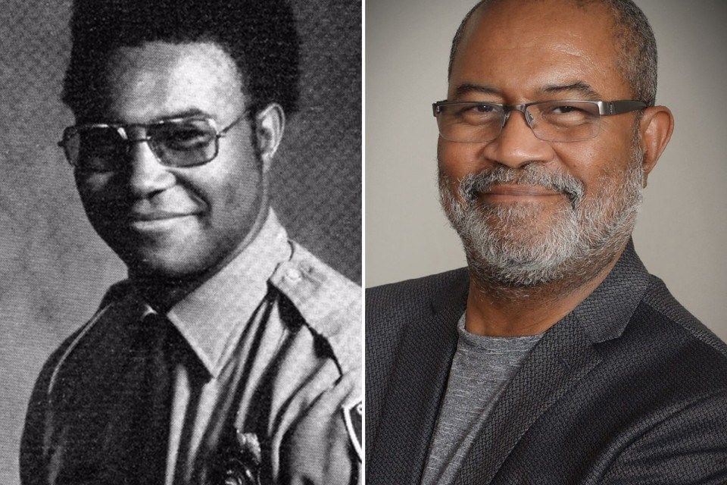

Ron Stallworth in the 1970s and a recent photo of him. (Courtesy of Ron Stallworth)

*“With that, Stallworth began a seven-month undercover investigation, infiltrating the Klan with the help of the white colleague who pretended to be him. He duped KKK Grand Wizard David Duke, whom Stallworth called regularly to get information on Klan activity. Duke had no idea the man he was talking to on the other end was black. But Stallworth said he was conducting an “intelligence investigation. From intelligence standpoint, we were successful. No cross burnings in 7½ months during this investigation. There were not because I was invited to participate in the cross burning.” When Stallworth got a tip, the police department would send police cars to the location of the planned cross burning*.”

1. **Author’s claim** (what he/she wants us to believe, **OPINION + REASON**):___________________

_______________________________________________________________________________

_______________________________________________________________________________.

2**. Text Evidence** for claim with **MLA:** **TE= proof: stats, facts, examples **MLA= author’s last name in parenthesis at the end of each piece of TE: “Blah-blah-blah” **(Author’s LAST name)**.

3. The author’s purpose is to _________________________ **(persuade, give opinion)** and he/she achieves the purpose through the following  **techniques/ examples: *(FOR EXAMPLE - Statistics: 99.9% of high schoolers do not read directions)***

1. Technique & example:
2. Technique & example:
3. Technique & example :

4. The author’s main audience **specifically** is___________________________________________

***because***________________________________________________________________________

_______________________________________________________________________________.

5. The author establishes a _____________________ **tone** (look at word choice) through the following **QUOTED words/phrases**



6. **Three words** I didn’t know (or ESSENTIAL words) WITH **DEFINITIONS**



7. **Occasion:** The **event** that prompted this text is _________________________ **(be specific)**

Because_________________________________________________________________________

_______________________________________________________________________________.