**A.O.W. #6: Due Thursday! Name: Hour:**

1. **Chunk the article** into manageable (2 paragraphs max.) pieces. **Number them**. Don’t forget the title/opening!
2. Highlight at least **three words you are not familiar with** and **define them** on the graphic organizer.
3. Show evidence of a close reading. Mark up the left side of the text (each chunk) with questions and/or comments that demonstrate interacting with the text. You may also include any confusion you have.
4. Complete the attached graphic organizer to analyze author’s craft

# Who Will Save the Savior Sibling? By: **Maura Dickey - May 13, 2016**

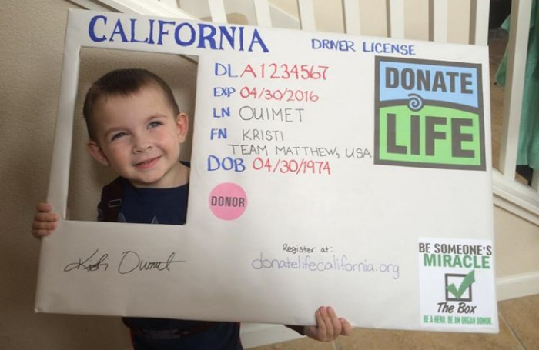

If we are going to treat children as if they are merely made of harvestable parts, then we should also establish legal standards that provide an independent advocate for the savior sibling. Often people will buy old computers or cars for spare parts. Though this is reasonable, should the same concept apply to having a child for their spare parts?

In 1991, the birth of Adam Nash, the first genetically designed IVF “savior sibling”, introduced this unprecedented concept. Savior siblings are the product of pre-implantation genetic diagnosis (PGD) with human leukocyte antigen (HLA) matching. This type of IVF allows parents to test embryos for well-matched genes to their already existing child, and then implant that embryo. Creating a child using this screening means that the savior sibling could function as a child live-organ donor, because they are well-matched in HLA to their sick sibling recipient.

The noble intention behind creating savior siblings should not go unrecognized. However, bringing children into the world because they have an ideal genetic makeup promotes the idea that children are merely commodities, their existence contingent on their ability to save the life of a sibling. While a theoretical understanding of savior siblings presents significant cause for concern, even more troubling is the fact that there is no existing federal regulation of PGD-with-HLA or means of legal protection provided to savior siblings. This absence of relevant legislation is further complicated by the strong similarity of ethical considerations associated with PGD-with-HLA matching procedures to procreative autonomy, which the Supreme Court has recognized as a constitutionally protected fundamental right.

In addition to ethical concerns, there is a major gap between this advancement in biotechnology and a necessary legal framework to address it. Perhaps the law will eventually catch up to science, but it is imperative that legal standards be set because these savior siblings are minors. The same parents who brought them into the world also act as their legal representation and decision makers. This leaves the savior siblings who don’t want to provide a live-organ donation helpless, as they cannot control their medical decisions. The only hope these children have under current law - the generally recognized fundamental right of parents to make decisions about their children without undue paternalistic interference - is if the government exercises the *parens patriae* power, the government authority to intervene in parental actions to protect the child.

To recognize these minors’ status as persons, the government needs to vastly extend the conditions necessary for legal live-organ donation. Since assisted reproduction technology is increasingly more popular, regulating the creation of savior siblings through PGD-with-HLA matching is virtually impossible. It would me much more efficient for legislators to focus efforts toward providing protection and recourse for the children who are the products of the procedure. Without federal direction, the states could regulate, allowing for intervention into parental behavior and decision-making under the aegis of the state’s definition of minors rights. Such regulations could prevent live-organ harvesting of children, even if they were born to be a sibling donor, until the child can provide informed consent or make a conscious decision about what to do with her body parts. Still, the American Academy of Pediatrics views live-organ donation by minors as acceptable only under extraordinary circumstances. These statutes may sound vague, but in comparison to no regulation at all, the would provide at least a modest solution.

If we are going to treat children as if they are merely made of harvestable parts, then we should also establish legal standards that provide an independent advocate for the savior sibling. It is uncommon for such a polarizing practice to be left unaddressed, particularly in the realm of protecting or exploiting human dignity. The rapidly evolving arena of bioethics is a force to be reckoned with, threatening to dismantle the traditional view that the parent knows best. But to frame the conditions for such an ethically questionable practice is far better than simply continuing to stand by and do nothing.

1. **Author’s claim** (what he/she wants us to believe, **OPINION + REASON**):

2**. Text Evidence** for claim with **MLA:** **TE= proof: stats, facts, examples **MLA= author’s last name in parenthesis at the end of each piece of TE: “Blah-blah-blah” **(Author’s LAST name)**.



3. The author’s purpose is to _________________________ **(persuade, give opinion)** and he/she achieves the purpose through the following  **techniques/example *(FOR EXAMPLE - Statistics: 99.9% of high schoolers do not read directions)***

a. Technique & example:

b. Technique & example:

c. Technique & example :

4. The author’s main audience is____________________________________**(Be specific)**

***because***____________________________________________________________________________________________________________________________________________________________________________________________________________________________________.

5. The author establishes a __________________________ **tone** (look at word choice) through the following **quoted phrases**:

6. **Three words** I didn’t know (or ESSENTIAL words) WITH **DEFINITIONS:**