**A.O.W. #5: Due Friday! Name: Hour:**

1. **Chunk the article** into manageable (2 paragraphs max.) pieces. **Number them**. Don’t forget the title/opening!
2. Highlight at least **three words you are not familiar with** and **define them** on the graphic organizer.
3. Show evidence of a close reading. Mark up the left side of the text (each chunk) with questions and/or comments that demonstrate interacting with the text. You may also include any confusion you have.
4. Complete the attached graphic organizer to analyze author’s craft

# Take the Lead to Sidestep Herd Mentality

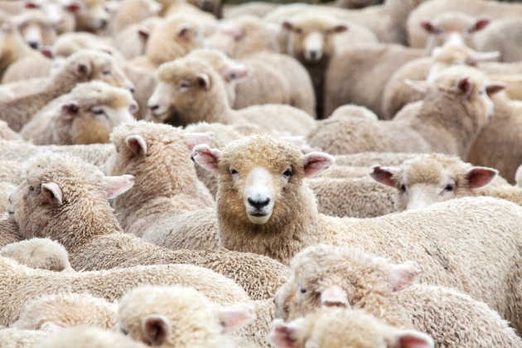By: Bob Kowalski - October 30, 2018

When Merriam-Webster [added 300 words](https://www.usatoday.com/story/life/2018/09/24/scrabble-finally-adds-ok-ew-dictionary/1408096002/) to its Scrabble dictionary recently, the company that made its name in language played directly to the fans of the popular board game. A couple of the additions also pointed out a trend of follow-the-leader. Among the new words usable in the game were "sheeple" and "hivemind." Outside of Scrabble, though, those words can lead to a herd mentality among both leaders and teams.

You might have experienced those terms in the workplace, if not verbally then visually. By definition, sheeple are easily influenced individuals, and hivemind means the "collective thoughts, ideas, and opinions of a group of people … regarded as functioning together as a single mind," [Merriam-Webster states](https://www.merriam-webster.com/dictionary/hive%20mind).

Now that we’re in the midst of a political season, the term sheeple is used frequently about the followers of particular candidates, parties or ideologies. But it can apply to the workplace too, and can cripple creative thinking. Sure, collaboration is valuable — even essential — at work, but groupthink comes with dangers.

For one, it can stifle innovation. Harvard instructor Anne Manning speaks to that with authority. In addition to her duties at one of the nation’s premier higher-learning institutions, she’s the founder of Drumcircle, a marketing and innovation firm. So she knows the value of distinct ideas.

"Individuality is a necessary ingredient for creative thinking," [Manning said in a post](https://www.extension.harvard.edu/professional-development/blog/welcome-authenticity-prepare-innovation) on the Harvard Extension School website.Standing on your own, away from the group, takes courage, conviction and integrity. It also requires — requires — a solid foundation. Make sure you have the information and data to support your commitment. It’s not enough to just go against the grain. You’ll also need to convince others to take up your case.

Your approach will need tact, too. Don’t step on toes just to show how smart you are, or show off your leadership qualities. Leadership will be exhibited in the outcome, not the show.

Compassion also is part of the plan. Keep in mind that others in the group have done their homework and explored other avenues, so don’t be a naysayer.

A thing that frequently drives herd mentality — and the bad decisions that sometimes can result from that – is the desire to fit in. [Researchers at Exeter University](http://rsif.royalsocietypublishing.org/content/12/103/20140893) determined that "groups evolve to be unresponsive to changes in their environment and spend too much time copying one another, and not making their own decisions."

Collaboration can work in a team environment when all the pistons are firing. But what happens when an overpowering personality steps to the front? The group can lean that way, preferring to "go along to get along," especially if that person has a strong ally or two. And introverts might be reluctant to draw attention in any group circumstance, let alone those in which they’re lower on the office hierarchy. In cases such as that, diversity of personalities is no guarantee of a forward-thinking outcome.

A diverse team brings benefits, but those individuals should be put in a position in which their value emerges readily, in groups or separately.

The iconic quote from late Apple CEO Steve Jobs explains that perfectly: "It doesn't make sense to hire smart people and tell them what to do; we hire smart people so they can tell us what to do," he said. That’s a way to foster creativity, and Apple’s track record supports that.

Supervisors and group members all have a responsibility to invest in collaboration, allowing them to avoid herd mentality.

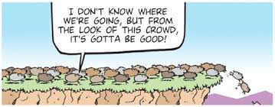

**www.ciaquared.net**

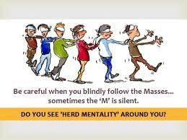

**Thomas Sowell- “Herd of Independent Minds”**

1. Author’s claim (what he/she wants us to believe, **OPINION + REASON**):

2**. Text Evidence** for claim with **MLA:** **TE= proof: stats, facts, examples **MLA= author’s last name in parenthesis at the end of each piece of TE: “Blah-blah-blah” **(Author’s LAST name)**. **REMEMBER THE PHOTOGRAPH AS T.E.!!!**







3. The author’s purpose is to _________________________ **(persuade, give opinion)** and he/she achieves the purpose through the following  **techniques/example *(FOR EXAMPLE - Statistics: 99.9% of high schoolers do not read directions)***

a. Technique & example:

b. Technique & example:

c. Technique & example :

4. The author’s main audience is________________________________ **(Be specific)** ***because***____________ _________________________________________________________________________________________________________________________________________________________________________________.

5. The author establishes a ________________________ **tone** (look at word choice) through the following **quoted phrases**:

6. **Three words** I didn’t know (or ESSENTIAL words) WITH **DEFINITIONS:**