Name_____________________________________________ hr. _________

**TPS-View and discuss the image below with your partner. INFER and provide EVIDENCE for the following:**

1. The time period and place of the setting is _________ because (providence evidence) ___________________________________________________________________________.

____________________________________________________________________________.

1. The man seated in the chair is probably ___________________ because _________________

____________________________________________________________________________.

1. The men surrounding the man on the chair are probably ___________ because ___________

____________________________________________________________________________.

1. The scene that is about to take place is ____________________________________________

because _____________________________________________________________________

____________________________________________________________________________.

1. The mood of the picture is ____________ because ___________________________________.

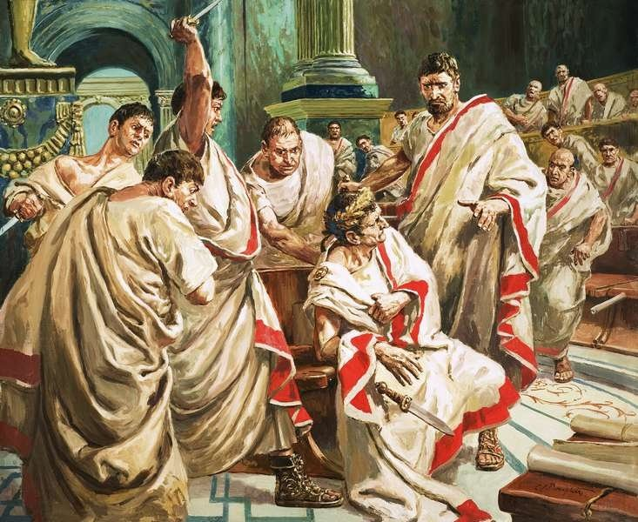

**\*\*\*Individual work--READ pages 818-822 in your textbook and answer the following questions on the back of this paper. Write in COMPLETE sentences unless it is a one word answer.**

1. Political powers will try to persuade with both ____________ and ______________.
2. Who was Julius Caesar? _________________________________________________

_____________________________________________________________________.

1. Where did Shakespeare get his information about Caesar? ______________________

______________________________________________________________________.

1. What **technique** is mainly used in drama to introduce the reader to characters and conflicts? ___________________________________________________________________________
2. What supports are in the text to help a reader **paraphrase**? __________________________

__________________________________________________________________________.

1. Write an **antonym**(opposite) for the words: a.) surly______________ ___&

b.) spare _______________.

7. What is the name of the teacher of rhetoric? _________________

8. What is the name of Caesar’s wife? ___________________

9. What does **triumvir** mean? __________________________________________

10. What is the **setting** of the play? __________________________________