***Rama’s Initiation*  Name_______________ hr. ___**

**Directions: Fill in events that fit/define each stage.**

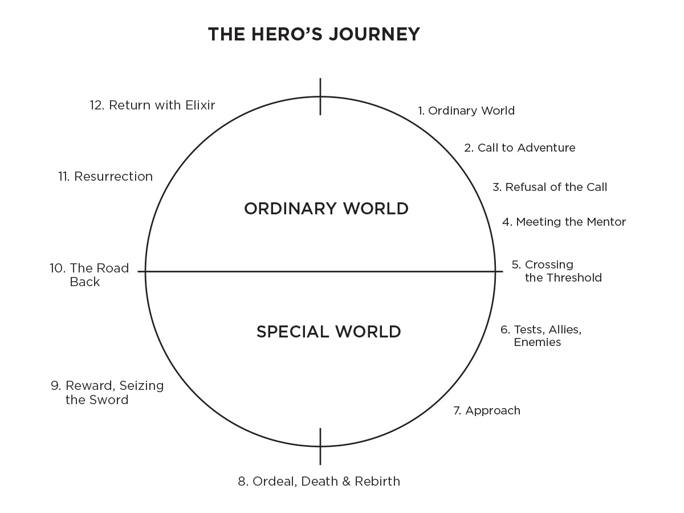

**Archetypes:**