**A.O.W. # 1 Due: Friday! Name: Hour:**

1. Chunk the article into manageable (2 paragraphs max.) pieces. Number them. Don’t forget the title/opening!
2. Highlight at least three words you are not familiar with or that are important and define them on the graphic organizer.
3. **Show evidence of a close reading. Mark up the left side of the text (each chunk) with questions and/or comments that demonstrate interacting with the text. You may also include any confusion you have.**
4. **Complete the attached graphic organizer to analyze author’s craft.**

**Giving schools a later start would create a huge financial benefit**

By Washington Post, adapted by Newsela staff; 09/08/2017

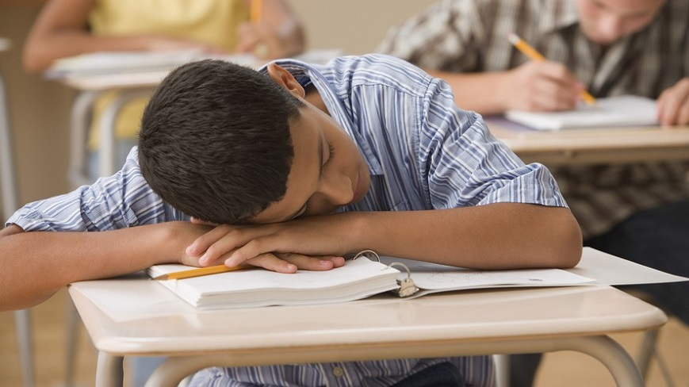

The United States would see roughly $9 billion a year in economic gains by making a simple, nationwide policy change: starting public school classes no earlier than 8:30 a.m.

That's according to an exhaustive new study by the Rand Corporation, a research group. It is the first of its kind to model the nationwide costs and benefits of later school start times.

The economic benefits would come primarily from two sources: greater academic performance, and hence, lifetime earnings, among more well-rested students, and reduced rates of car crashes among sleepy adolescent drivers.

Those benefits would greatly outweigh the annual costs of implementing the policy change. One cost is the price of reorganizing school bus schedules, estimated at $150 per student per year. Another is a flat, one-time cost of $110,000 per school to install additional resources. For example, more lighting might need to be added for later dismissals, sports team practices and other student activities.

**Change Would Be A Win-Win**

"The significant economic benefits from simply delaying school start times to 8:30 a.m. would be felt in a matter of years, making this a win-win, both in terms of benefiting the public health of adolescents and doing so in a cost-effective manner," said Wendy Troxel in a news release. She is a co-author of the study.

Co-author Marco Hafner added that the rapid return on investment from implementing the change is "unprecedented in economic terms."

In recent years researchers have identified early school start times as a significant public health problem. Adolescents' brains are wired to go to sleep late and wake up late, making it difficult for them to get a good night's sleep before a 7:30 a.m. first period class. Sleep deprivation in teens has been linked to everything from poor health to bad academic performance to criminal activity.

"The evidence strongly suggests that a too-early start to the school day is a critical contributor to chronic sleep deprivation among American adolescents," the American Academy of Pediatrics wrote in 2014. "The AAP urges middle and high schools to aim for start times that allow students to receive 8 1/2 to 9 1/2 hours of sleep a night. In most cases, this will mean a school start time of 8:30 a.m. or later."

**Very Few Schools Start That Late**

The overwhelming majority of schools do not start that late, however. Only 18 percent of the nation's school districts start classes at 8:30 a.m. or later, according to the Centers for Disease Control and Prevention. Nationwide the average starting time for high school and middle school classes is 8:03 a.m. In some states it's considerably earlier — Louisiana starts classes at around 7:40 a.m., on average. Many schools in the state start even earlier than that.

School districts have traditionally balked at rearranging their schedules, however. A chief obstacle is transportation: school districts usually send high school students to class earlier than elementary school kids, allowing for a staggered bus schedule, a smaller bus fleet and fewer drivers.

Ditching that system to get everyone to school at the same time would require more buses and drivers. It would cost a school district roughly $150 per student, according to a 2011 Brookings Institution analysis. Beyond that, the Rand researchers note that schools would need to invest in lighting and other infrastructure to support after-school activities happening at later hours.

**Benefits Far Outweigh The Cost**

But these costs are dwarfed by the economic benefits of starting school later. States implementing later school times would see a positive return on their investment in just two years, according to the Rand report. The net nationwide benefit from increased academic performance and lower car crash rates would reach $9.3 billion a year. That amount is equivalent to the annual revenue of Major League Baseball.

The authors stress that they're likely understating the true economic benefits of earlier start times. They don't attempt to model potential spillover benefits in other areas, like student mental health, obesity or criminal behavior.

"The reported benefits in this study are likely an underestimation of the full benefits" of delaying school start times to at least 8:30 a.m., the authors note.

1. Author’s claim (what he/she wants us to believe—OPINION + REASON)):
2. . Text Evidence for claim *with MLA*: **TE= proof: stats, facts, examples

**MLA= author’s last name in parenthesis at the end of each piece of TE: “Blah-blah-blah” (Author’s LAST name).

1. ________________________________________________________________________

________________________________________________________________________

1. ________________________________________________________________________

________________________________________________________________________

________________________________________________________________________

1. ________________________________________________________________________

_________________________________________________________________

1. _________________________________________________________________

_________________________________________________________________

**(inform, persuade, give opinion, etc.)**

1. The author’s main purpose is _________________because_________________________

_______________________________________________________________________________

**(Be specific)**

1. **The author’s main audience is __________________________because______________**

__________________________________________________________________________

1. The author establishes a _____________ tone (look at word choice) through the following techniques (include technique and *specific explanation* (questions *about blah blah*, or pictures *to capture interest, etc*.) a._______________________________________________,

b._____________________________________________, and c.________________________________.

1. 3 words I didn’t know (or are ESSENTIAL words) WITH DEFINITIONS

a.

b.

c.