**A.O.W. #8 Due: Monday! Name: Hour:**

1. Chunk the article into manageable (2 paragraphs max.) pieces. Number them. Don’t forget the title/opening!
2. Highlight at least three words you are not familiar with or that are important and define them on the graphic organizer.
3. Show evidence of a close reading. Mark up the left side of the text (each chunk) with questions and/or comments that demonstrate interacting with the text. You may also include any confusion you have.
4. Complete the attached graphic organizer to analyze author’s craft.

A Timeless Thirst for Power

The Political Lessons of ‘Julius Caesar’

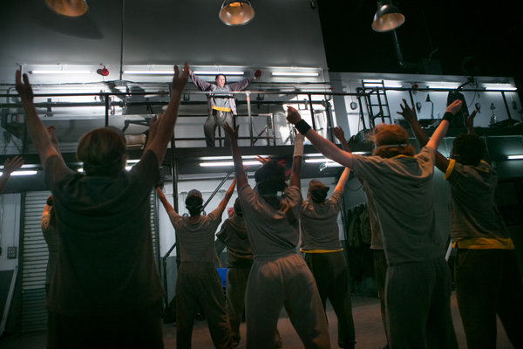 [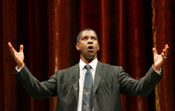](javascript:pop_me_up2('http://www.nytimes.com/imagepages/2013/10/09/theater/09caesar-washington.html','09caesar_washington_html','width=720,height=543,scrollbars=yes,toolbars=no,resizable=yes')) **Sara Krulwich/The NY Times**

**Frances Barber, above, in "Julius Caesar" at St. Ann's Warehouse.**

**A country is thrown into chaos when its leaders descend into conflict in Shakespeare’s “Julius Caesar.” Does this sound slightly familiar?**

The Rome depicted in Shakespeare’s play and our own fractious democracy are of course hardly equivalent. But it is an odd coincidence that at a time when the country appears to be on the brink of confusion — with the fate of the world’s financial markets hanging in the balance, or so we are told — New York should be hosting [a new production](http://theater.nytimes.com/2013/10/10/theater/reviews/shakespeares-julius-caesar-by-women-of-donmar-warehouse.html?ref=theater) of one of Shakespeare’s most overtly political plays, and one, furthermore, in which scheming politicians wreak havoc on what had been a functioning state.

As the Shakespeare scholar Marjorie Garber notes in her book “Shakespeare After All,” this particular play “is as likely to be taught and read today in classes on political theory, business, and “leadership” as it is in the context of Shakespeare and his literary contemporaries,” adding that the play speaks “pertinently, and impertinently, to the modern and postmodern condition, to modern history, and to modern politics, rhetoric and oratory.”

Were you to go probing for specific parallels of the current moment, you might fancifully see the far-right wing of the Republican party as similar to at least some of the Roman conspirators who are determined to bring down the mighty Caesar in Shakespeare’s play. While the American president is hardly a figure ruling with the power of a Caesar, there does sometimes seem to be an almost obsessive desire on the part of the Tea Party and its Congressional supporters to oppose the President’s will at every turn.

Obviously I don’t mean to suggest that any cabal of Congressman plans to pull out the knives in a conference in the Oval Office, but their animosity toward the chief achievement of the Obama presidency — the health care plan grinding into operation just as the government has been effectively shut down — does seem to resemble Cassius’s maniacal envy of Caesar’s power, as when Cassius crankily observes:

*Why, man, he doth bestride the narrow world*

*Like a Colossus, and we petty men*

*Walk under his huge legs, and peep about*

*To find ourselves dishonourable graves.*

You could also compare Cassius’s manipulation of Brutus into joining the conspiracy to the manner in which the hard-liners in the House of Representatives are causing Speaker John Boehner to be torn between conflicting factions. (That said, Mr. Boehner hardly professes to be the devoted friend to Obama that Brutus does to Caesar.)

Certainly I’m putting forth these comparisons for the sake of amusement — and Lord knows we could all use some diversion right now. But it is continually a marvel that Shakespeare’s drama contains such an astute analysis of the way men with a taste for power behave : the egoism that blinds Caesar to even the possibility of his losing power, let alone being assassinated; the unctuous words with which politicians attempt to cover their nefarious deeds (see Brutus’s speech to the public to explain the motivations for the killing of Caesar); the still more unctuous words with which politicians praise their foes even as the subtext of their words indicate just the opposite (see Mark Antony’s famous oration following Brutus’s, in which he appears to laud Brutus for his participation in the killing as, with each lofty phrase, he implies the opposite).

Also oddly pertinent in a contemporary context is the tendency of politicians to assume that the public shares their desires, as the conspirators wrongly assume they will be hailed as heroes for having brought down the great Caesar.

Perhaps the most unsettling theme in “Julius Caesar,” seen through the prism of today’s politics, is the danger that threatens when the public perceives a void of power at the seat of government. With a steady drumbeat of hand-wringing filling the newpapers as the deadline for raising the debt ceiling approaches, you read of the confusion that floods Rome in the wake of Caesar’s death with a sting of dismay.

As is clearly enough apparent in “Julius Caesar” and some of his other plays, Shakespeare was hardly a believer in the ability of the common man to behave in a sensible fashion when a country’s leaders lead them astray or rouse them to partisan furies. One of the most chilling — and gruesomely funny — scenes in “Julius Caesar” depicts a hopped-up rabble of plebeians mistaking the poet Cinna for the conspirator Cinna, and then deciding with a shrug to assault him anyway: “It is no matter, his name’s Cinna.” Obviously Americans of the 21st century are hardly likely to behave with similar disregard for basic civility — not to mention reason — but the stalemate in Washington does not seem to be tempering the polarization of our political culture, but exacerbating it.

After noting that “Julius Caesar” has been rewritten by Brecht and “appropriated” by Karl Marx, Ms. Garber’s essay on the play leaves us with a final reminder that trying to draw specific moral or political lessons from Shakespeare’s play can be a tricky business. In the final analysis, “its lessons are elusive.”

That is certainly true, but it is also the case that classic works of theater can sometimes speak to us most vividly, and urgently, when the eternal truths of human behavior they illuminate can, say, be seen glaring at us from television screens on a nightly basis. And perhaps we can take some comfort in the arrival of the Donmar Warehouse production of the play at this particular time: as bad as things are now in America, they could just possibly be worse.

1. Author’s claim (what he/she wants us to believe—OPINION + REASON)):
2. Text Evidence for claim *with MLA*: **TE= proof: stats, facts, examples

**MLA= author’s last name in parenthesis at the end of each piece of TE: “Blah-blah-blah” (Author’s LAST name).

1. ________________________________________________________________________

________________________________________________________________________

1. ________________________________________________________________________

________________________________________________________________________

________________________________________________________________________

1. ________________________________________________________________________

_________________________________________________________________

1. _________________________________________________________________

_________________________________________________________________

(inform, persuade, give opinion, etc.)

1. The author’s main purpose is _________________because_________________________

_______________________________________________________________________________

**(Be specific)**

1. **The author’s main audience is __________________________because______________**

__________________________________________________________________________

1. The author establishes a _____________ tone (look at word choice) through the following

techniques (refer to technique list, but make it **specific**):

a._________________________________________, b. __________________________________, and

c.___________________________________________________________________.

1. 3 words I didn’t know (or are ESSENTIAL words) WITH DEFINITIONS

a.

b.

c.