**A.O.W. #6 Due: Monday! Name: Hour:**

1. Chunk the article into manageable (2 paragraphs max.) pieces. Number them. Don’t forget the title/opening!
2. Highlight at least three words you are not familiar with or that are important and define them on the graphic organizer.
3. Show evidence of a close reading. Mark up the left side of the text (each chunk) with questions and/or comments that demonstrate interacting with the text. You may also include any confusion you have.
4. Complete the attached graphic organizer to analyze author’s craft.

**Detroit eyed for container-based replica of Shakespeare's Globe Theatre**

**Jenn McKee, Special to the Detroit Free Press***11:03 p.m. EDT November 5, 2016 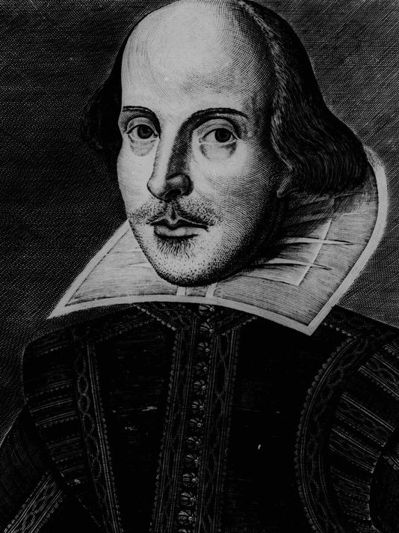(Photo: AP)*

**Detroit could become home to the world’s first punk rock re-imagining of Shakespeare’s circular Globe Theatre, constructed with large, corrugated metal shipping containers.**

The brainchild of New York-based New Zealander and Shakespeare fanatic Angus Vail — manager of the rock band Kiss’ business office since 1995 (via Joseph Young Associates), and former in-house business manager for INXS — the Container Globe would mimic the specifications of the original Globe in size and shape, and it would most likely be built along the Woodward Corridor. One possible site is a parking lot at Woodward Avenue and Canfield Street.

“The lot is under consideration,” said Bud Liebler, who owns that parking lot and the Whitney restaurant, in addition to running a public relations agency (with his son, Patrick Liebler) that’s working for Vail. “The theater would ‘fit’ there, and because of its location in the heart of Midtown and the Cultural District, it could be an ideal location, but no final determination has been made.”

According to a press release, Vail has had preliminary discussions regarding the Container Globe project in other cities, including Denver and Los Angeles, but he’s primarily focused on Detroit, engaging with potential local funders and sponsors, as well as with City Hall and local arts organizations. Up to this point, Vail has funded the planning stage of the Container Globe project, working with a New York-based design firm called Arup Engineering. The project’s lead architect is Nicholas Leahy, of Perkins Eastman, and the structural engineer is Michael Ludvik. But has any additional funding been secured? “The answer is no, but we haven’t been aggressive yet in going after it,” said Liebler. The project will cost an estimated $6 million, with an estimated timeline of 18 months (no opening date has been set). Vail and his team plan to launch a Kickstarter campaign in February 2017.

“I’d like to build or bring Globes to many places in the U.S., and the world,” said Vail. “The London Globe has been very supportive because they are keen to bring their productions and actors to play in a venue that is pretty much the same environment as their Globe. Plus, the London Globe has a very strong education program, and we believe that we’ll be able to provide a great educational program.”

Why is Vail so excited by the prospect of re-creating the atmosphere of the original Globe Theatre, the London theater closely associated with Shakespeare?

“The Globe environment is about the fact that the audience and the players are up close, and can see and interact with each other,” said Vail. “The audience can sometimes be almost another player, or sometimes the mirror or conscience of the actor. So when Hamlet does his ‘To be, or not to be,’ he’s engaging the audience, not just talking out into the darkness. Plus, the London Globe actors have learned how to use that space, that environment, and the audiences are used to it and often happy to participate or react. It’s a much more unpredictable, spontaneous and interactive venue than a regular theater. That’s why I want to build one in the U.S.”

The Container Globe would be constructed from triple-stacked, 20-foot long, modified, corrugated metal shipping containers — except for the stage and backstage levels, which require 40 foot containers — and covered with a wind- and rain-resistant mesh. Plans call for a patron capacity of 1,200 (650 on bleachers in the shipping containers, 550 in “the yard,” which is standing-room-only). Ticket prices for Shakespearean events would likely range from $10 or less (for access to “the yard”) to $75.

In a press release, Vail said, “We want the Yard tickets to be less than the price of a movie ticket — so almost everyone can afford to see great Shakespeare — and we think we’ll attract lots of students, millennials and young people just curious about this bold new theater, who want to engage in and lead the audience’s involvement in the plays.”

One of the selling points of the proposed Container Globe project is its mobility; the theater, once built, could be broken down and rebuilt in a new location. Plus, the Container Globe, operating between April and October, would host a broad variety of events, exhibits, and performances, including dance recitals, concerts, theater, a sculpture garden and more.

Why did Vail decide that he wanted Detroit to be the Container Globe’s inaugural launching pad? In part, Detroit’s status as the birthplace of both an industry and a genre of music make it a good fit. But it’s more than that. “I’m actually super excited to build the first Globe in Detroit,” said Vail. “I think it’s a fascinating place. I’ve been there lots in the past year or two and have seen the transformation. It’s great to see it bounce back after the bankruptcy. Still a long way to go, but I love the spirit of the town. I’d love the Globe to be part of that.”

1. Author’s claim (what he/she wants us to believe—OPINION + REASON)):
2. . Text Evidence for claim *with MLA*: **TE= proof: stats, facts, examples

**MLA= author’s last name in parenthesis at the end of each piece of TE: “Blah-blah-blah” (Author’s LAST name).

1. ________________________________________________________________________

________________________________________________________________________

1. ________________________________________________________________________

________________________________________________________________________

________________________________________________________________________

1. ________________________________________________________________________

_________________________________________________________________

1. _________________________________________________________________

_________________________________________________________________

**(inform, persuade, give opinion, etc.)**

1. The author’s main purpose is _________________because_________________________

_______________________________________________________________________________

**(Be specific)**

1. **The author’s main audience is __________________________because______________**

__________________________________________________________________________

1. The author establishes a _____________ tone (look at word choice) through the following techniques (refer to technique list, but make it **specific**) a._____________________

____________________, b. ____________________________, and c._________________________.

1. 3 words I didn’t know (or are ESSENTIAL words) WITH DEFINITIONS

a.

b.

c.