A.O.W. #6 Op-Ed Name: Hour:

- Chunk the article, a blog post, into manageable (2 paragraphs max.) pieces. Number them. Don’t forget the title/opening!
- Highlight at least three words you are not familiar with or that are important and define them on the graphic organizer.
- Show evidence of a close reading. Mark up the left side of the text with questions and/or comments that demonstrate interacting with the text. You may also include any confusion you have.
- Complete the attached graphic organizer to analyze author’s craft.

Be a mogul: What you can learn from Jay Z and DJ Khaled
Josh Linkner, Special to the Detroit Free Press11:12 p.m. EDT April 16, 2016

He’s appeared as a guest on nearly every talk show. Millions have viewed his Snapchat videos, memes and “keys to success” as he’s quickly become a household name. Yes, hip-hop artist DJ Khaled is everywhere. This self-proclaimed mogul’s success tips seem never ending, but is he the real deal or a flash in the pan?
That same question was once asked about Jay Z, yet today his success in undeniable. His ascent from the projects to a penthouse has inspired the world, and he’s been a driving force in the music scene for two decades. Estimates of his net worth put him above half a billion dollars, his Roc Nation group manages every aspect of sports and entertainment imaginable. Jay sold his clothing line, Rocawear, for over $200 million, he more than doubled the value of his minority stake in the Nets, he owns restaurants and clubs, and this proud papa is also married to Beyoncé.
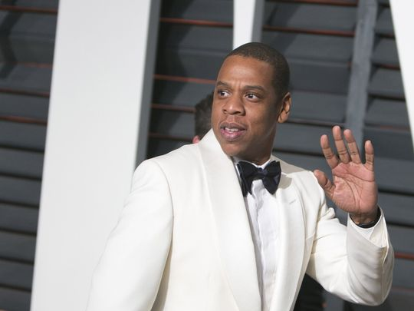
Jay Z as he arrives to the Vanity Fair Oscar Party on Feb. 22, 2015, in Beverly Hills, Calif. He may be many things, but a flash in the pan Jay Z is not. (Photo: Adrian Sanchez-Gonzalez/AFP-Getty Images)

He may be many things, but a flash in the pan Jay Z is not. Over the years, he has proven to be a sharp, innovative mogul with a Midas touch. While DJ Khaled is making his rounds on the Internet, Jay Z is behind the scenes creating art. DJ Khaled is right now, but Jay Z has shown he has the chops for the long haul.

Here are four key differences between Khaled and Jay Z that can help propel your own success to "Empire"-like status:
1. Intention.
Though doing a top-notch job of capitalizing on his newfound popularity, DJ Khaled shows no signs of having thought much of anything through. His infamous late-night Jet Ski trip that left him lost along the Florida coastline is a great example.
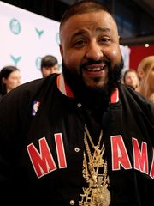
Hip-hop artist DJ Khaled is everywhere. Here, he attends the Shorty Awards at the Times Center on April 11, 2016, in New York City. (Photo: D Dipasupil, Getty Images for The Shorty Awards)

Jay Z, on the other hand, seems to do nothing haphazardly. That’s not to say that he doesn’t take risks, but he plays the game like a chess grandmaster. Jay Z thinks many moves ahead and connects each deliberate action with the precision of a surgeon. It’s allowed him to build continuous momentum rather than succumbing to a series of false starts.
2. Focus on excellence.
DJ Khaled is constantly talking about his success, but what’s unclear is what exactly he’s accomplished. Boasting does not equal accomplishment.
In contrast, Jay Z has substance along with sizzle. He’s deeply committed to his craft, constantly pushes artistic boundaries and never coasts on past wins. Jay Z has the humility to admit when mistakes are made, and the ability to improve from setbacks. One artist commits to delivering the goods, while the other’s only gift is crafting a shiny — yet flimsy — veneer.
3. Learning.
Jay Z’s resume is eclectic. He has collaborated with Rihanna, Linkin Park, Kanye, Alicia Keys, Coldplay and even his mom. When Jay Z talks about these endeavors, he describes them as both artistic partnerships and unique learning experiences. Despite being one of the best-selling rappers of all time, Jay still considers himself a student of music and his fellow artists.
DJ Khaled’s work, on the other hand, is mainly about himself. When you’re doing all the talking, you don’t leave room to listen, learn and grow. This blowhard will likely fade away because he doesn’t show a love of learning.
4. Embrace failure.
DJ Khaled conveniently doesn’t mention failing, except in the general sense, as something you set your mind against. As if you can build up a mental wall so that it will never happen. He doesn’t talk about specific failures or how they factor into his vision of success.
For Jay Z, failure is part of success. He’s said that he has learned more from his failures than his successes. Looking at his life and career, it’s hard to think of something that Jay Z hasn’t succeeded at. But he doesn’t rest on his laurels or bill himself as a savant. Instead, he reminds us that has he failed and those failures have helped him to become who he is today.
Intention. Excellence. Learning. Failure.
When embraced, these four principles can drive sustainable success. Ignore them, and you run the risk of fizzling out. It’s one thing to reach some level of success, yet an entirely different thing to stay there. Ten years from now, Jay Z will remain impactful and relevant while DJ Khaled will be long forgotten. Embrace the strategy of legends, not loudmouths, to blow past the wanna-bes and achieve your full potential.
Josh Linkner is a successful tech entrepreneur, author and keynote speaker. He writes a weekly column for the Sunday Business section and freep.com. Linkner is the founding partner of Detroit Venture Partners, cofounder of Fuel Leadership and author of two New York Times Bestsellers: “Disciplined Dreaming” and “The Road to Reinvention.” For more info, check out joshlinkner.com or follow him on Twitter @joshlinkner.

- Author’s claim (what he/she wants us to believe—OPINION + REASON)):

- . Text Evidence with MLA: **TE= proof: stats, facts, examples
**MLA= author’s last name in parenthesis at the end of each piece of TE: “Blah-blah-blah” (Author’s LAST name).
- ________________________________________________________________________

________________________________________________________________________

- ________________________________________________________________________

________________________________________________________________________

________________________________________________________________________

- ________________________________________________________________________

_________________________________________________________________

- _________________________________________________________________

_________________________________________________________________

(inform, persuade, give opinion, etc.)

- The author’s main purpose is _________________because_________________________

_______________________________________________________________________________
(Be specific)
- The author’s main audience is __________________________because______________

__________________________________________________________________________

.The author establishes a _____________ tone (look at word choice) through the following techniques (refer to technique list, but make it specific) _______________

_______________, __________________________________, and ______________________.

- 3 words I didn’t know (or are ESSENTIAL words) WITH DEFINITIONS
a.
b.
c.

