A.O.W. #1**: Due: Monday**

**Directions**

1. Chunk the article into manageable (2 paragraphs max.) pieces. Number them. Don’t forget title/opening!
2. Highlight at least three words you are not familiar with or that are important and define them. (on back)
3. Show evidence of a close reading. Mark up the left side of the text chunks with questions and/or comments that demonstrate interacting with the text. You may also include any confusion you have.
4. Identify on the right side of the chunked paragraphs the Purpose, Audience, Techniques, and Tone used by the author. Remember, these can change from one paragraph to another**.** “Serious” or “formal/informal” is vague if repeated too often. Be specific!
5. Complete the attached graphic organizer to analyze author’s craft.

Top of Form

**Britain's Cameron Urges Support for Syrian Refugees in**

**Lebanon, Jordan**[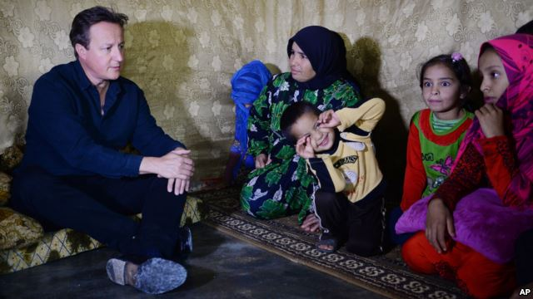](http://gdb.voanews.com/89D456D3-DE84-4830-9C7E-0E47D9DDCDBB_cx0_cy5_cw0_mw1024_s_n_r1.jpg)

British Prime Minister David Cameron meets Syrian refugee families at a tented settlement camp in the Bekaa Valley on the Syrian - Lebanese border, Sept. 14, 2015.

**Reuters**Multimedia

September 14, 2015 7:45 PM

BEIRUT/AMMAN—

British Prime Minister David Cameron said on a visit to Lebanon and Jordan on Monday that it was vital to provide support for refugees from Syria's civil war within the region to discourage them from risking their lives in trying to reach Europe.

Under pressure from Europe to take in far more refugees to help with a migrant crisis in the European Union, Cameron pledged last week that Britain would take in up to 20,000 people from refugee camps in Lebanon and elsewhere in the region. Britain has also promised 100 million pounds ($154.5 million) to help Syrian refugees in several countries, with up to 29 million pounds going to Lebanon.

Cameron visited refugees in an informal tented settlement in Lebanon's Bekaa Valley, where many live without easy access to electricity and clean water, and praised Lebanon's efforts when he met Prime Minister Tammam Salam in Beirut. "I was in the Bekaa Valley seeing for myself that hospitality and meeting some of the Syrian refugees that we will resettle in the United Kingdom," he said.

He later flew by helicopter to Jordan's Zaatari camp, one of the largest camps hosting refugees along the border with Syria, before meeting King Abdullah in Amman.There he spoke of the need to support the refugees within the region to discourage them from making the dangerous journey to Europe. "It is so important to help keep people close to their homes, clothe them, feed them and house them so they don't take the perilous journey across the seas which has led to such appalling losses of life" he said.

Since 2011, the conflict in Syria has driven more than 4 million people into refugee camps in surrounding countries like Turkey, Jordan and Lebanon, and many others towards Europe. Lebanon has called on other countries to share its refugee burden. The United Nations refugee agency says there are around 1.1 million refugees in Lebanon, or one person in four in the country, and at least 620,000 U.N.-registered refugees in Jordan. Lebanon and Jordan say international aid meets only a fraction of the billions of dollars that it costs them to host the refugees, straining their infrastructure and basic services.

The flood of migrants arriving in Europe over the summer has prompted some leaders to announce a greater refugee intake. Germany says it expects an estimated 800,000 people to arrive this year - four times as many as last year. The civil war in Syria has killed 250,000 people and forced half of the population from their homes, creating the worst refugee crisis since World War II. About 7.6 million people are displaced within the country.

Lebanon's Salam said his country was struggling to cope with the influx from its much larger neighbor, especially given that some international aid had been cut. "We are convinced that the refugee crisis which reached the crux of Europe today is a phenomenon that cannot come to a halt unless we find a political solution to put an end to the war in Syria," he said.

Cameron discussed with Salam and the Jordanian king the threat of the Islamist militants who control swaths of territory in Iraq and Syria. Britain will continue to support the Lebanese security services and boost defence co-operation with Jordan, he said. "Of course that threat is more acute here with ISIS-held territory just 60 miles from your border," Cameron told Salam, referring to land held by Islamic State militants in Syria. King Abdullah of Jordan, which is part of the U.S.-led coalition fighting the militants, said "the global fight against terror is a major challenge" for his country and the region.

**Author’s claim: ________________________________________________________________________________________**

**_____________________________________________________________________________________**

**1. Text Evidence (proof: stats, facts, examples)**

1. **________________________________________________________________________________  
     
   ________________________________________________________________________________**
2. **________________________________________________________________________________**

**________________________________________________________________________________**

1. **________________________________________________________________________________**

**________________________________________________________________________________**

1. **________________________________________________________________________________**

**________________________________________________________________________________**

**2. The author’s main purpose is __________________________ because _____________________**

**_________________________________________________________________________________.**

**3. The author’s main audience is ________________________ because ________________________  
  
___________________________________________________________________________________.**

**4. The author establishes a ______________________ tone through the following techniques (refer to**

**technique list) ____________________, _____________________,and___________________________.**