s

**Announcements**

●The zoo field trip is scheduled for May 19th. Please let us know if you are willing to chaperone. We can only take 4 parents on the bus, but would love to have more parents meet us there.

# Math

●This week we will be reviewing fractions ½ , ¼, etc. We will continue to practice 2 digit subtraction (55-24= __) and writing numbers in expanded form 24 = 20+4. Our test will be next week.

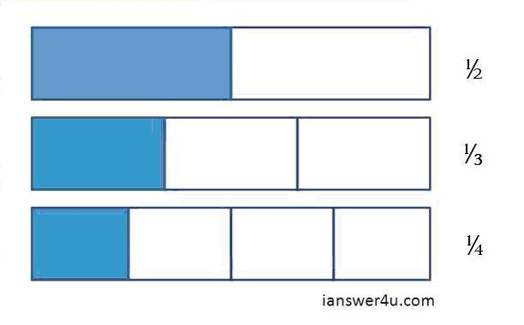

Figure

**PHONICS**

● This week students will be reading and writing words with the y ending sound.

Spelling

Our spelling words this week are:

Sky, happy, fly, baby, cry, sunny

Science

This week we will continue our discussion about life cycles. We will be exploring the life cycles of a butterfly and a frog.

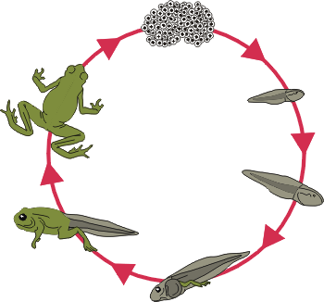

Spring time is a wonderful time to keep our eyes open for baby animals!

NWEA

Our NWEA dates have changed. We will now be taking the reading portion on Thursday, May 5th and the Math on Thursday, May 12th. Please continue to practice Education City games. These games will review skills covered by the NWEA. If the first grade games are too easy please check out the second grade games.

First Grade

Classroom Newsletter

**Week of:**

**April 18th**





First Grade Classroom Newsletter Page 2

