s

**Announcements**

●Report cards were passed out on Friday of last week, be sure to look in your child’s folder!

● Friday and Monday, no school due to mid-winter break!

● Valentine’s Day Party on Thursday, more information to follow.

# Math

●This week students will be learning about fact families.

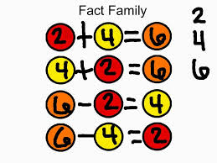

**PHONICS**

● This week students will be reading and writing words with the sound of /ou/

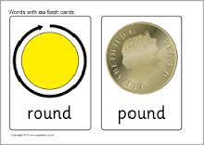

Spelling

Our spelling words this week are:

Cloud, round, out, loud, her, is

Spelling test will be this Tuesday 2-16-2016.

Social Studies

●We are learning about location! Practice your exact home address with your child!

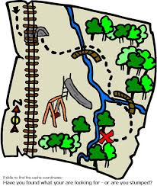



First Grade

Classroom Newsletter

**Week of:**

**February 8**





First Grade Classroom Newsletter Page 2

