s

**Announcements**

●Friday will be our PBIS reward day, check your child’s behavior chart if your child has 3 or more yellow days, 2 or more oranges, or 1 or more reds, they will not be participating in reward day. If you would like to volunteer to help during reward day, please see me for time and details.

# Math

●This week students will be reviewing fact families and finding missing numbers or equations within a fact family.

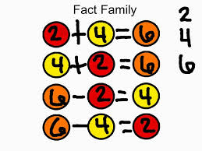

* Our next Math test will be Monday, February 29th. A review packet will come home Thursday!

**PHONICS**

● This week students will be reading and writing words with the ing sound.



ring

Spelling

Our spelling words this week are:

king, bring, thing, looking, sing, swing

Social Studies

●We are learning about location! We will be working on left and right, and regions this week.

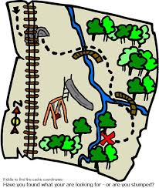

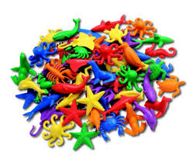

First Grade

Classroom Newsletter

**Week of:**

**February 22**

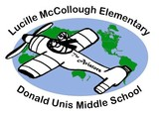

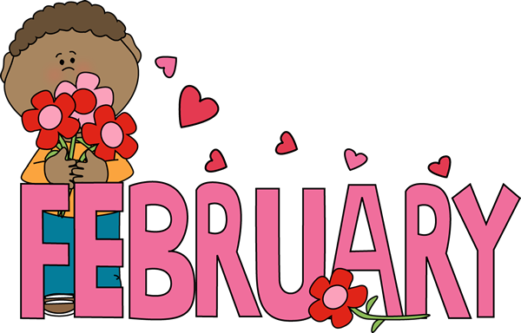

First Grade Classroom Newsletter Page 2

