s

**PHONICS**

● This week students will be working on the ay words.

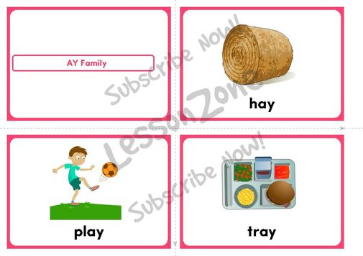

Spelling

Our spelling words this week are:

***day, may, stay, away, say***

Sight words: ***want, look***

Our spelling tests will Monday, because of the half day on Friday. Your child will be tested on the 7 words above. I will also ask your child to spell 2 words that are not on this list. These words will have the pattern of the ay sound. I do this to assess your child on whether they grasped the concept of the phonic skill we worked on that week.

Science

We are continuing to learn about seasons and the weather! We will be wrapping up unit on weather, and checking to see what students have learned.











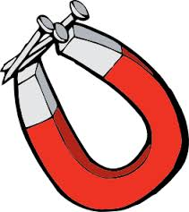







**Announcements**

*Tomorrow, January 26th, will be taking the students to see the performance of Charlotte’s Web at the Civic center. We will be leaving the school at 9:00 and returning at 12:00. We will be eating lunch in our rooms. Please send your child with a lunch tomorrow.

*The weather is becoming much colder; please make sure your child is dressed appropriately, sweaters and long sleeve shirts in the classroom! Your child will also need gloves and hats to stay warm while playing outside.

* Friday is a half day; your child will be dismissed at 11:10.

# Math

This week marks the end of Unit 5. We will be taking our math test on Thursday. Please complete the review packet at home and work with your child on any areas they might need extra help.

Please also visit educationcity.com, math, first grade, STAN’S PARTY. This will provide your child with extra practice on missing addends.

First Grade

Classroom Newsletter

**Week of:**

**January 25th**

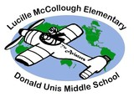



First Grade Classroom Newsletter Page 2

