s

**Week of:**

**December 4th**

**PHONICS**

● This week students will be reading and writing words with the sound of **the silent e .**

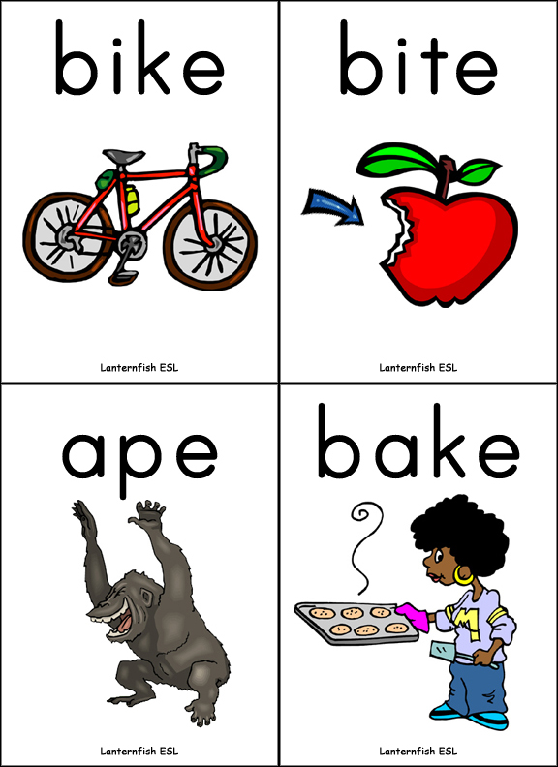

Spelling

Our spelling words this week are:

**Silent e words: make, came, lake, game, shake, ate**

**Sight words: not, do**

Our spelling tests will be every Friday. Your child will be tested on the 8 words above. I will also ask your child to spell 2 words that are not on this list. These words will have the pattern of the silent e. I do this to assess your child on whether they grasped the concept of the phonic skill we worked on that week.

Social Studies:

We will continue our study on needs, wants, goods, services, and trade. Please ask your child to tell you what these words mean in their own words.







First Grade

Classroom Newsletter

# Math

This week we will focus on making numbers in different ways (2+3=5 and 4+1=5) and also continue to hammer home combinations that equal 10.

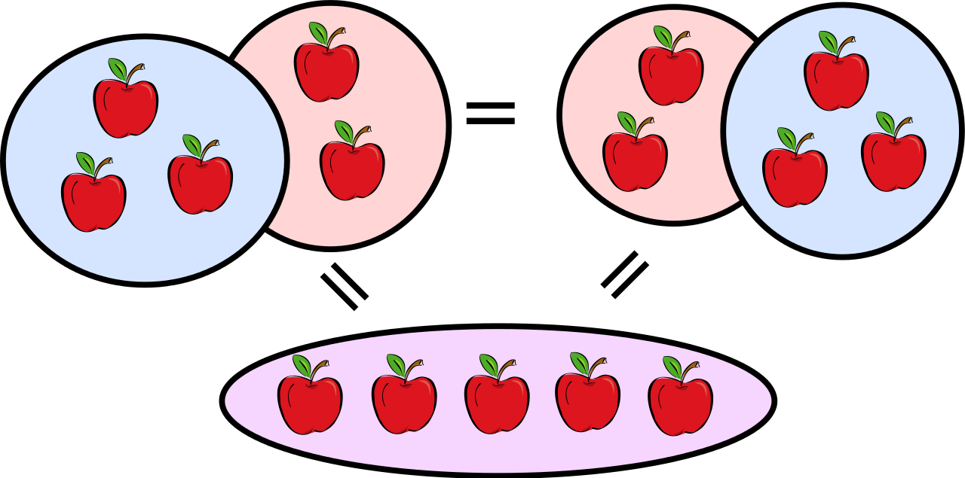

Reading

Please make sure that your child is reading from their book bag or books on raz-kids each night. Reading each night is what makes the difference between good readers and struggling readers.

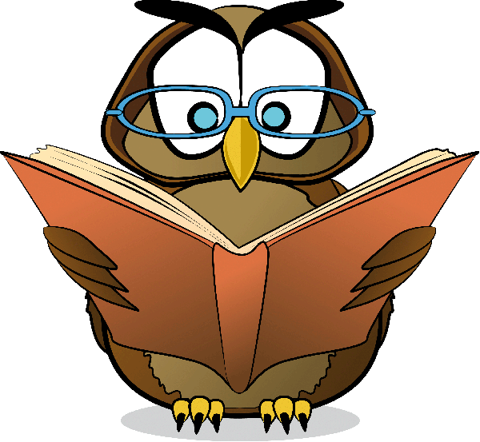

Announcements

*Book fair will be up in the library this week. If you would like your child to buy books, Please send money to school in envelope marked “book fair”.

*Mobil Dentist forms are due Wednesay.

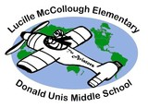



First Grade Classroom Newsletter Page 2

