Thanksgiving Break Homework!

Please allow your child to read on Raz –kids or from their book bags for at least 20 minutes each day. Color a turkey for each day of reading.

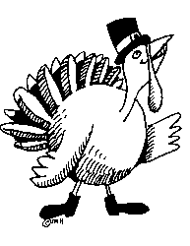

Please also have your child practice addition, subtraction, or clock math games on Education City or one of the other math sites on our blog. <http://iblog.dearbornschools.org/stipanovich/> If you do not have a computer have your child practice addition facts (5+6, 4+3, etc..). Color a pilgrim for each day of math practice.



Science Review

Each child has a science book in their book bags. Please review pages F26-F39 on magnets.