s



**PHONICS**

● This week students will continue reading and writing words with the sound of **the h brothers**. Our spelling words will have the pattern of the h brothers.

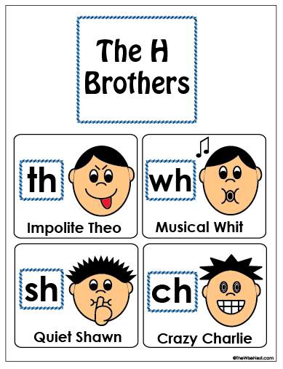

Spelling

Our spelling words this week are:

**path, bath, rich, chat, shut, shed, are, was**

Our spelling tests will be every Friday. Your child will be tested on the 8 words above. I will also ask your child to spell 2 words that are not on this list. These words will have the pattern of short a sound. I do this to assess your child on whether they grasped the concept of the phonic skill we worked on that week.

Science

We are learning about magnets! Have your child locate things in your home that will attract a magnet.













**Announcements**

●Parent teacher conferences continue Wednesday and Thursday for parents with appointments.

●Late Start Wednesday November 18th, school starts at 9:00.

●Please make sure your child comes in on time, instruction starts promptly at 8:05.

# Math

This week in math we will focus on telling time. Being able to tell time to the hour and half hour using a digital and analog clock. Have your child find digital and analog clocks around your home.

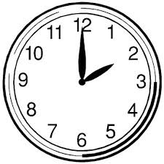

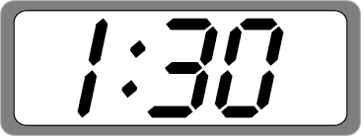

First Grade

Classroom Newsletter

**Week of:**

**November 16**





First Grade Classroom Newsletter Page 2

