s

**PHONICS**

● This week students will be reading and writing words with the sound of **short u**. Our spelling words will have the pattern of short u.

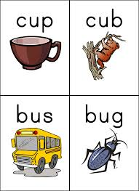

Spelling

Our spelling words this week are:

**mud, fun, run, us, up, to, my**

Our spelling tests will be every Friday. Your child will be tested on the 7 words above. I will also ask your child to spell 2 words that are not on this list. These words will have the pattern of short a sound. I do this to assess your child on whether they grasped the concept of the phonic skill we worked on that week.

Social Studies

● Students will continue to learn about the importance of the US holidays such as Independence Day, MLK Day, Constitution Day, President’s Day, etc. We will also continue to explore the calendar and pick out the day of the week, month, date, etc.

First Grade

Classroom Newsletter

**ABC Get to Know Me Days**

Monday-F- Bring or draw a picture of your family

Tuesday-G- Bring or draw a picture of your grandparents

Wednesday-H- Bring or draw a picture of your house

Thursday-I- Get ready to share your favorite ice cream

Friday-J-Jump as we learn!

**Announcements**

● Wednesday October 7th is late start, students come to school at 9am.

●Friday October 9th students have Science Stations

● Friday October 16th students have a half day, dismissal 11:10

# Math

**Math test this Friday!!**

Friday will be our first math test and a study guide will be sent on Monday. The study guide is due on Thursday and we will go over it on this day. Please make sure to do a page a day or different sections a day.



**Week of:**

**October 5**

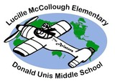

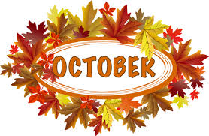

First Grade Classroom Newsletter Page 2

