s

**PHONICS**

● This week students will be reading and writing words with the sound of **the h brothers**. Our spelling words will have the pattern of the h brothers.

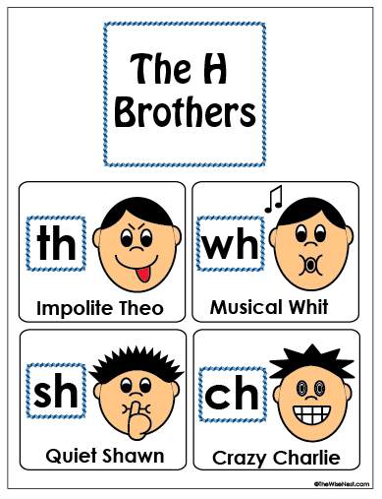

Spelling

Our spelling words this week are:

**that, this, them, shop, she, ship, is**

Our spelling tests will be every Friday. Your child will be tested on the 7 words above. I will also ask your child to spell 2 words that are not on this list. These words will have the pattern of short a sound. I do this to assess your child on whether they grasped the concept of the phonic skill we worked on that week.

Science

We will continue our unit of physical science with our five senses. We will also introduce sorting objects by size, color, shape, etc.

# Math

This week in math we will focus on story problems. Reading the problems and representing the numbers by drawing circles.

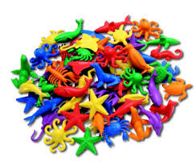



First Grade

Classroom Newsletter

**ABC Get to Know Me Days**

Monday-U- Uncles and aunts, bring a picture or drawing of your uncles and aunts.

Tuesday-V- Volume, practice classroom volume and outdoor volume.

Wednesday-W- When I grow up, what do you want to be when you grow up?

Thursday-X- eXtra Special day, tell us why you are an extra special person!

Friday-Y- Yesterday, what did you do yesterday, be ready to share.

**Announcements**

●Boo Grams for sale $0.50 cents a gram! Students send grams to their friends.

●Friday October 30th Halloween Parade, students will change into their costumes in school.

**Halloween**

On Friday afternoon we will be doing a few fun “Halloween” activities. We will be making playdough, making a spooky snack, and exploring pumpkins. We are in need of donations (flour, kool-aid packages, and pumpkins). I would also love to have a few parent volunteers to help us with our activities. Please let me know if you can help.

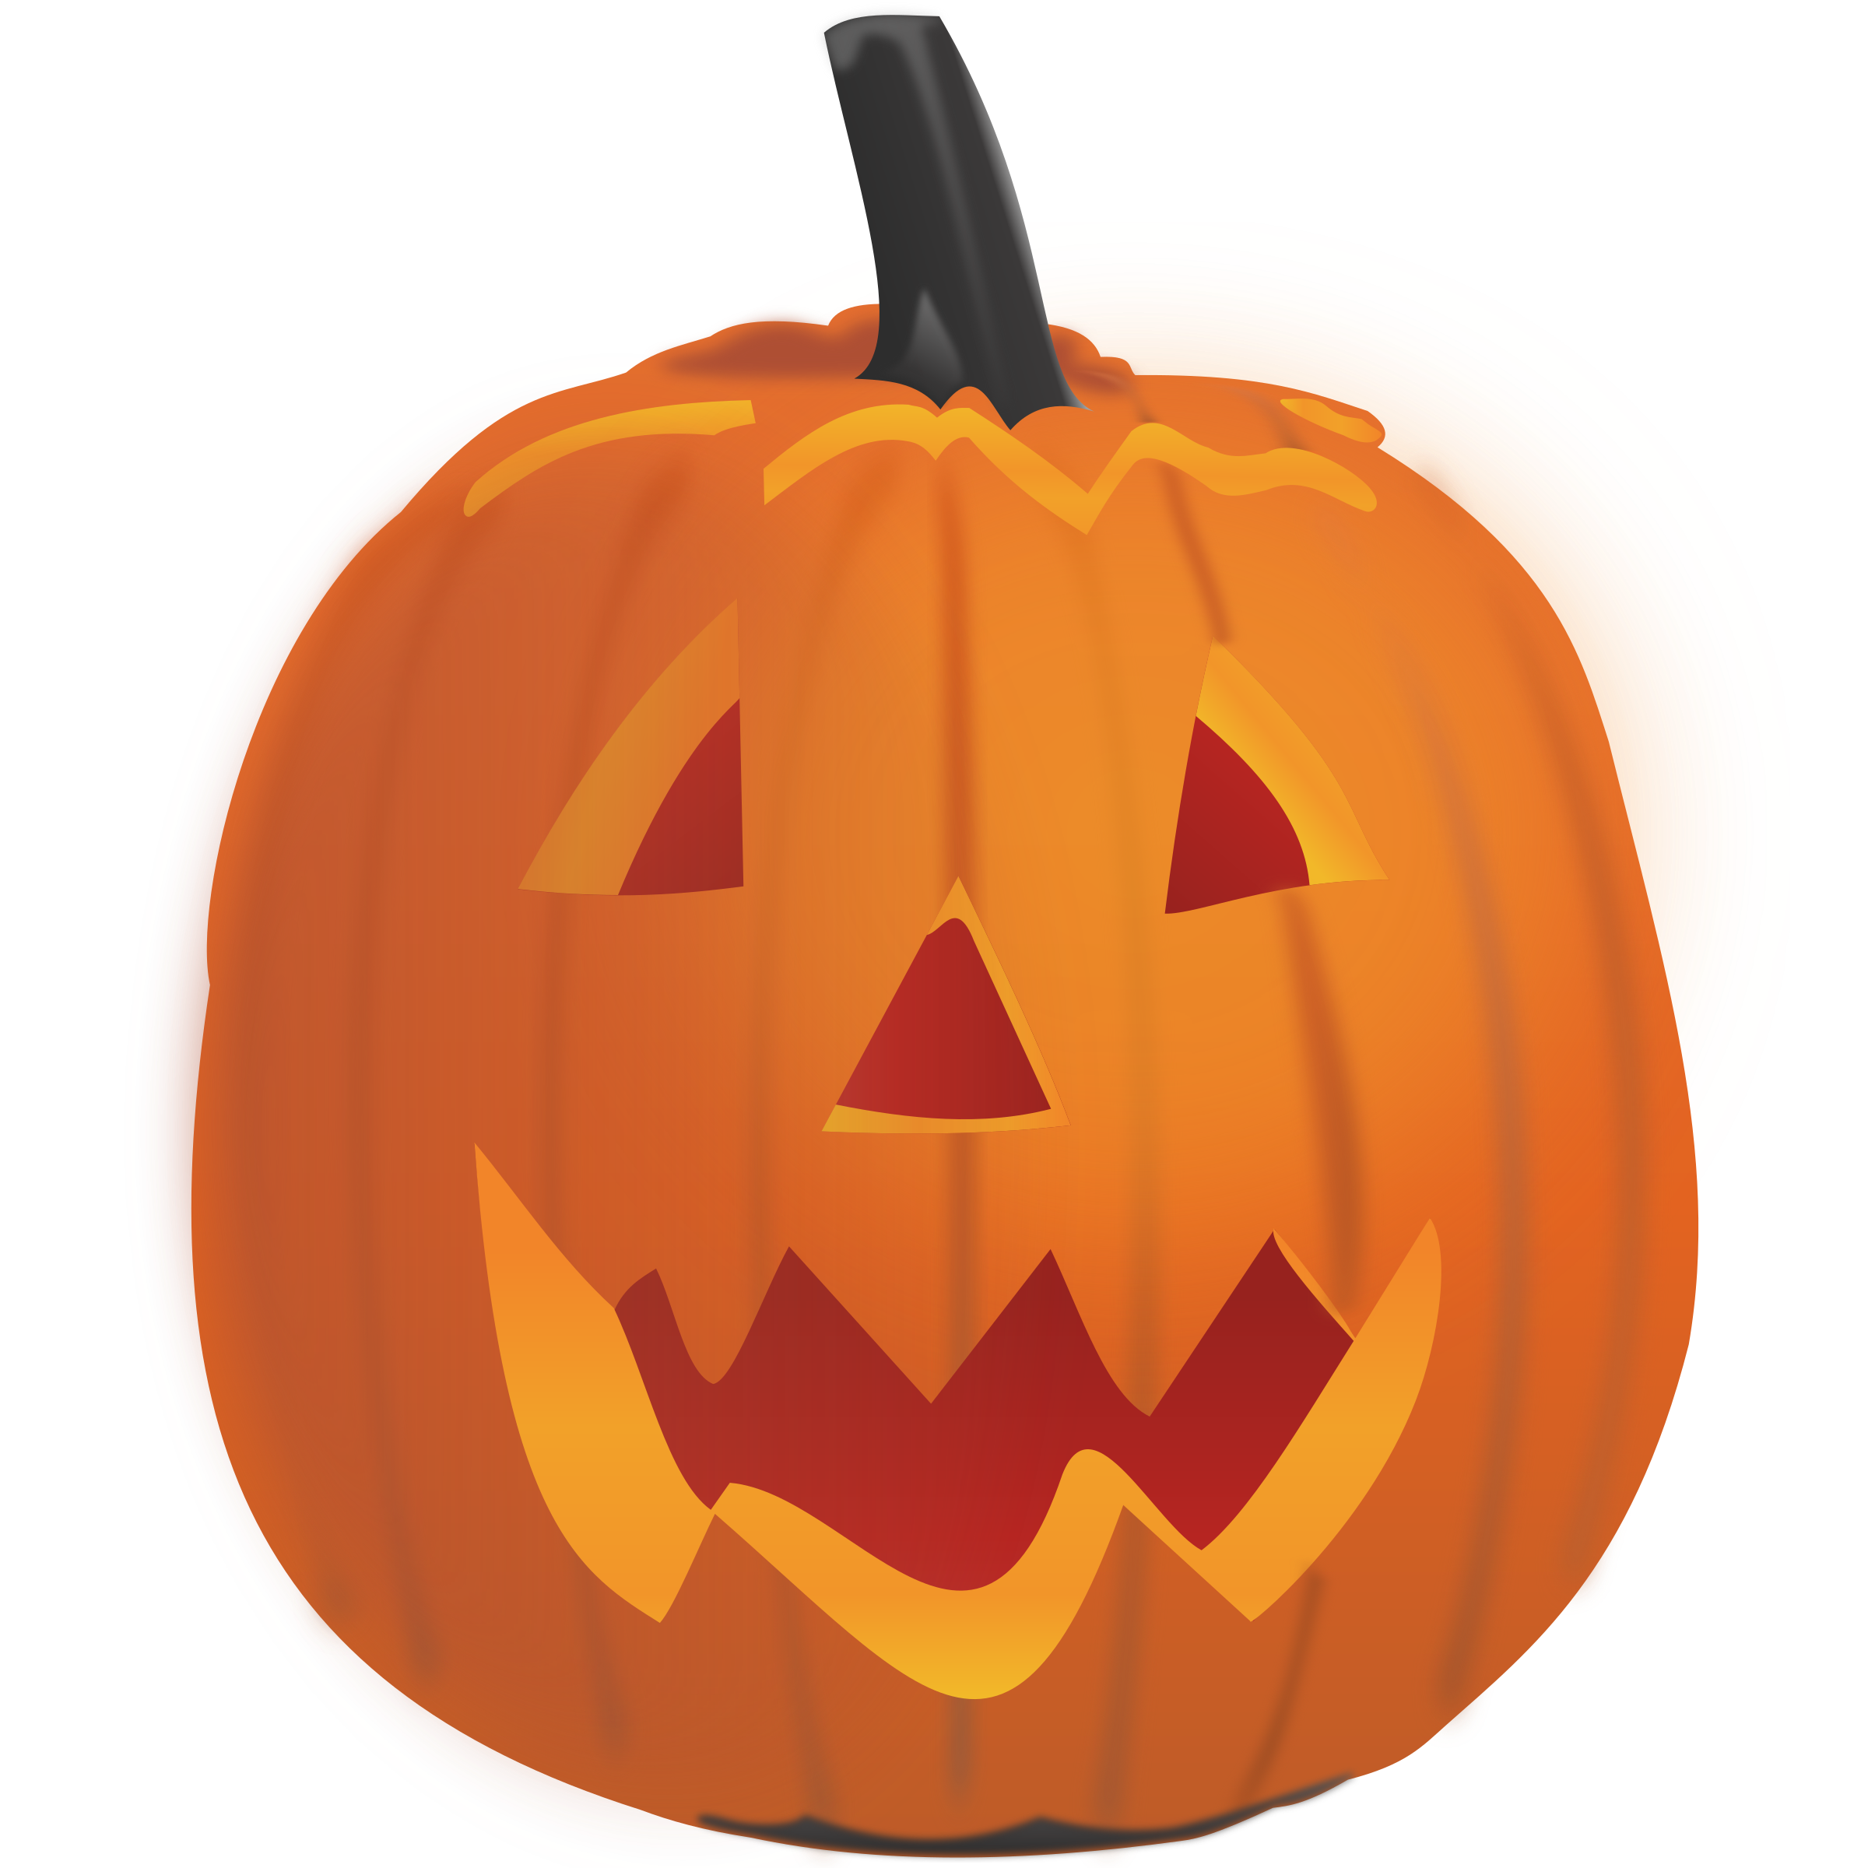

**Week of:**

**October 26**

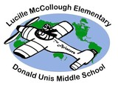

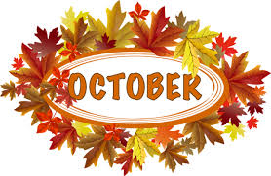

First Grade Classroom Newsletter Page 2

