s

**PHONICS**

● This week students will be reading and writing words with the sound of **short e**. Our spelling words will have the pattern of short u.

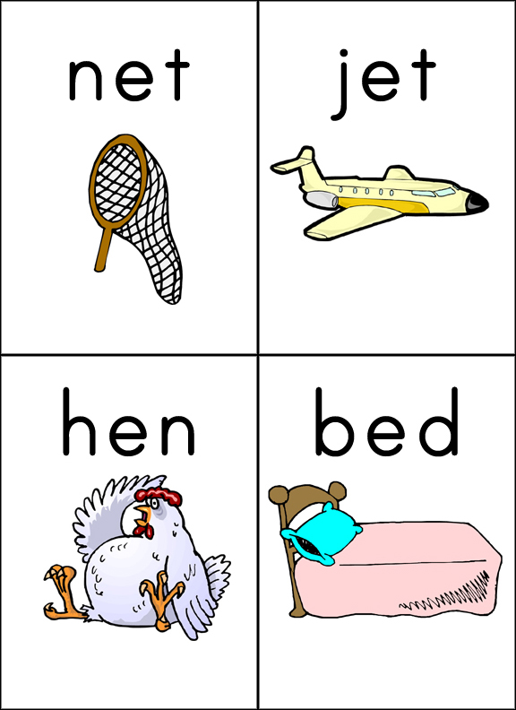

Spelling

Our spelling words this week are:

**let, get, pet, red, fed**

**be, play**

Our spelling tests will be every Friday. Your child will be tested on the 7 words above. I will also ask your child to spell 2 words that are not on this list. These words will have the pattern of short e sound. I do this to assess your child on whether they grasped the concept of the phonic skill we worked on that week.

Social Studies

● Students will finish up our Social Studies unit on the past, present, and future.

Science

This week we will begin out unit on Physical Science. We will put our senses to work making purposeful observations of a variety of objects.

First Grade

Classroom Newsletter

**ABC Get to Know Me Days**

Monday-P- Practice your phone number

Tuesday-Q- Work on using a quiet voice

Wednesday-R- Work on showing respect

Thursday-S- What Street do you live on?

Friday-T-Use your sense of touch to observe objects.

**Announcements**

● Tuesday, October 20th, The Ann Arbor hands on Museum will be back to do Math centers with the kids.

# Math

This week we will focus figuring out what 1 more or 1 less of any given number would be (5 is 1 less than 6).

We will also work on making 10. Our class will come up with multiply ways to make 10. Please help your child practice making 10 at home (If I have 2 how many more to make 10). The more quickly they can make 10 the easier math will be.

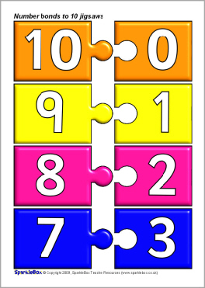

**Week of:**

**October 19**

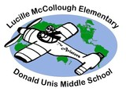



First Grade Classroom Newsletter Page 2

