s

**PHONICS**

● This week students will be reading and writing words with the sound of **short i**. Our spelling words will have the pattern of short i.

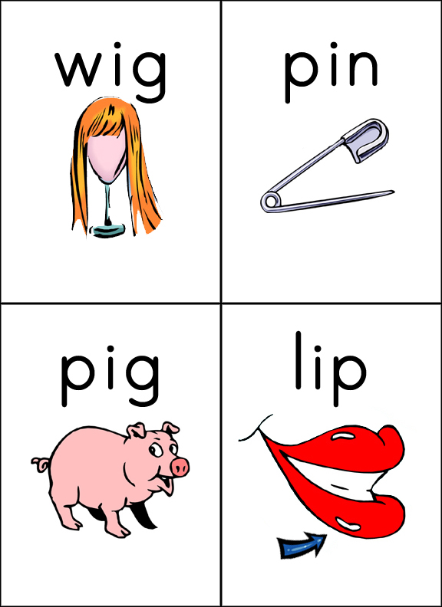

Spelling

Our spelling words this week are:

**Short I words - it, in, is, did, big**

**Sight words - and, me**

Our spelling tests will be every Friday. Your child will be tested on the 7 words above. I will also ask your child to spell 2 words that are not on this list. These words will have the pattern of short a sound. I do this to assess your child on whether they grasped the concept of the phonic skill we worked on that week.

Social Studies

● Students will be introduced to important US holidays such as Independence Day, MLK day, Constitution day, president’s day etc. We will also explore the calendar and pick out the day of the week, month, date, etc.

First Grade

Classroom Newsletter

**ABC Get to know me days**

Monday – A – Bring in your favorite stuffed animal

Tuesday – B – Bring in a baby picture of yourself

Wednesday- C- Bring something small that is your favorite color

Thursday – D- Bring a picture of your dad

Friday – E – Check your eye color so we can graph it in class today

 

# Math

During math students will be working on the following concepts:

● Counting on the number line.

● Counting up to 40 by grouping items by twos.

● Identifying the number that comes before and after.

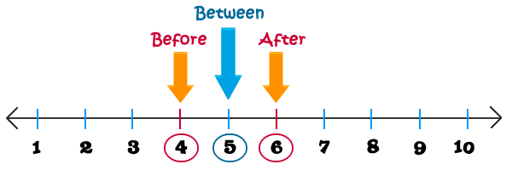

● Countingup to forty by grouping items by fives using tally marks.



**Week of:**

**September 28**

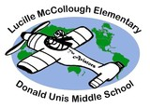

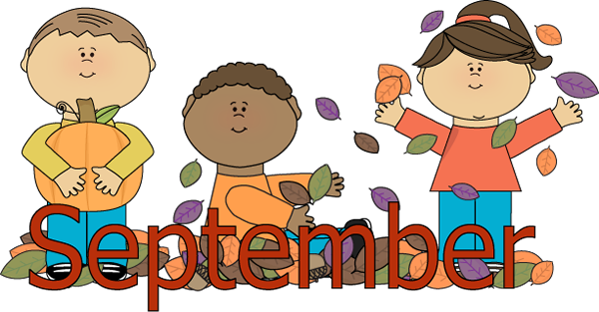

First Grade Classroom Newsletter Page 2

