Statistics 4.1—Probability Distributions

Objective 1: I can distinguish between discrete random variables and continuous random variables.
The outcome of a probability experiment is often a ___________ or a __________________. When this occurs, the outcome is called a __________________________.

A ________________________ x, represents a ___________________________ associated with each ________________ of a probability experiment.

The word _______________ indicates that x is determined by chance. There are two types of random variables: ________________ and ____________________.

A _______________ random variable has a _____________ or countable number of ____________ that can be listed. Generally the outcomes consist of ___________ numbers.

Examples:

*Discrete variables can be _______________.

A _______________ random variable has an ________________ number of _______________. These outcomes cannot be listed as they represent ______________ on a number line.

Examples:

*Continuous variables can be ___________________.

*Read bottom half of pg 194

*Read Example 1, pg 195

TIY 1: Decide whether the random variable x is discrete or continuous.
A) x represents the number of questions on a test.

B) x represents the length of time it takes to complete a test.
C) x represents the number of songs played by a band at a concert.
D) x represents the time, in minutes, that the band plays.

*The rest of this chapter focuses on discrete random variables.
Objective 2: I can construct a discrete probability distribution and its graph.
Each value of a discrete random variable can be assigned a probability. By listing each value of the random variable and its corresponding probability, we form a ________________________. Let’s create a probability distribution for rolling a 6-sided die.

There are two properties that will always be true of a discrete probability distributions.
In Words In Symbols
1)

2)

Because probabilities represent __________________________________, a discrete probability distribution can be graphed with a _________________________________________________.

Steps to constructing a discrete probability distribution
Let x be a discrete random variable with possible outcomes
1)

2)

3)

4)

*Read Example 2, pg 196

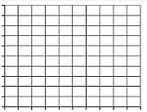
TIY 2: A company tracks the number of sales new employees make each day during a 100-day probationary period. The results for one new employee are shown below. Construct and graph a probability distribution.
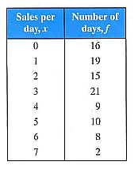

*Read Ex 3 & 4, pg 197 to see how to verify that a distribution IS a probability distribution.

TIY 3 and 4: Are the distributions below probability distributions? Explain why or why not.
A) B)
x | 0 | 1 | 2 | 3 | 4
y | 0.38 | 0.12 | 0.25 | 0.07 | 0.15
x | 0 | 1 | 2 | 3 | 4
y | 0.22 | 0.31 | 0.19 | 0.12 | 0.16

C) D)
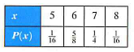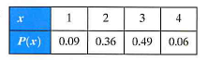

Objective 3: I can find the mean, variance, and standard deviation of a discrete probability distribution.
You can measure the center of a probability distribution with its ______ and measure the variability with its ___________ and _______________________ (SD).

The formulas to find the mean, variance, and SD are below.

The _________ of a discrete random variable is given by

*Basically, each value of ____ is multiplied to its _______________ and the products are ________.

The ____________ of a discrete random variable is given by

The ____________________ of a discrete random variable is given by

Ex 6: Let’s find the mean, variance, and SD of the probability distribution that showed the test scores for passive-aggressive traits.
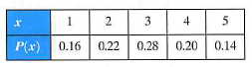

TIY 6: Find the mean, variance, and SD of the probability distribution in Ex 2 (below).
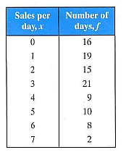

Objective 4: I can find the expected value of a discrete probability experiment.
The mean of a random variable represents what you would expect to happen for thousands of trials. It is also called the __________________________. The expected value of a discrete random variable is equal to the __________ of the random variable.

Expected Value =

Ex 7: At a raffle, 1500 tickets are sold for $2 each for four prizes of $500, $250, $150, and $75. You buy one ticket. What is the expected value of your gain?

*Although individual probabilities cannot be ________________, expected value can (and usually is).

Ex 8: EFHS is holding a raffle to raise money for the senior party. Tickets are $5 each and only 500 tickets will be sold. The prizes are $500, $250, and five people will win $75. You buy one ticket. Find the expected value of your gain.

