Stats 2.1 Bellwork Name: ______________________________

#1 Date: ______________

Find the class width for each frequency distribution.

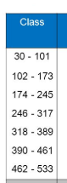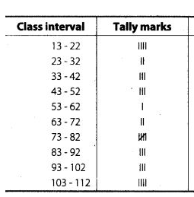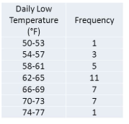A) class width = ________ B) class width = ________ C) class width = ________

D) Find the class width for a data sat that has a minimum value of 10, a maximum value of 50, and uses 5 classes.

class width = ________

#2 Date: _________

Use the frequency distribution at the right to answer questions 1 – 4.

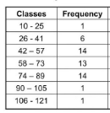1) What is the class width? _______

2) What is the midpoint of the 4th class? ______

3) What is ?

4) What is the relative frequency of the 3rd class?

#3 Date: __________

Fill in the missing info in the frequency distribution.

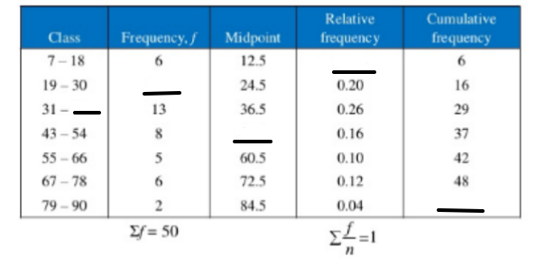

#4 Date: __________

Use the distribution to answer each question.

1. What is the class width? _____

2. Fill in the 2 missing class limits.

3. Fill in the missing midpoint.

4. Fill in the missing relative frequency.

5. Fill in the missing cumulative frequency.

|  |  |  |  |  |
| --- | --- | --- | --- | --- |
| **Class** | **Freq.** | **Midpoint** | **Relative freq.** | **Cumulative freq.** |
| * 50 | 12 | 25.5 | 0.18 | 12 |
| 51 - 100 | 18 |  | 0.27 |  |
| 101 – 150 | 7 | 125.5 | 0.10 | 37 |
| 151 – 200 |  | 175.5 | 0.13 | 46 |
| 201 – 250 | 5 | 225.5 | 0.07 | 51 |
| 251 – 300 | 6 | 275.5 | 0.09 | 57 |
| 301 - | 10 | 325.5 |  | 67 |

