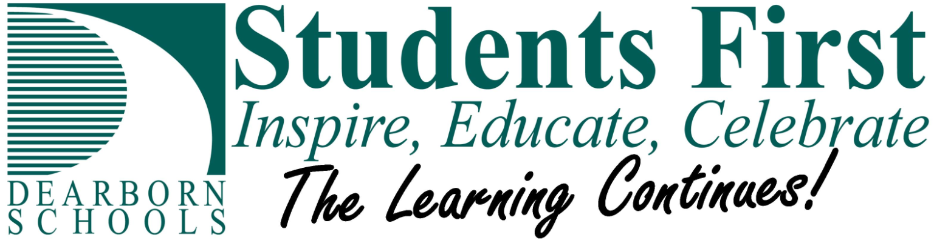

April 17, 2020

Greetings,

“The Learning Continues!” You will be seeing this phrase more often over the next two months as we have added this line to our very popular vision statement Students First: Inspire, Educate, Celebrate. Although our buildings are closed and the days ahead are still filled with a great deal of uncertainty, this one line truly captures the essence of our work for the remainder of the school year.

To further reinforce this commitment to our students, I am pleased to announce the Dearborn Public Schools Continuity of Learning Plan has been approved by our Wayne County RESA Intermediate School District (ISD) Superintendent. This is required action under Governor Whitmer’s Stay at Home Executive Order (E2020-35) which suspended in-person instruction for our students during the remainder of the school year. Approval of the plan allows our district to continue to receive funding from the state, but more importantly, it provides our staff members with a plan that will support student learning from April 20, 2020 through our last day of school on June 11, 2020.

Several key areas are specifically addressed in the plan including: Instruction, Student Participation, Chromebook Distribution, Content Delivery Methods, Consideration for Special Populations, Food Services, Managing and Monitoring Learning, and the identification of any additional cost to the District. The complete plan, a summary of how the plan impacts elementary, middle and high school students, along with grading criteria for each grade level can be found at:

<https://dearbornschools.org/services/dearborn-public-schools-continuity-of-learning-plan/>

As a nation we find ourselves in a fluid situation that includes plenty of unknowns. On behalf of our Board of Education and the entire staff of the Dearborn Public Schools, I want to assure parents that they can be certain we are all committed to support your children and their education for the remainder of the school year and the years ahead. Since we left our school buildings in March, I have witnessed outstanding examples of distance learning and teacher to student interactions that reinforce the bond between teachers and students. I believe it is this bond along with the tremendous support we have seen from our parents/guardians, that will ensure the learning continues for all students.

Please remain safe and I wish continued good health to all in our community.

Sincerely,

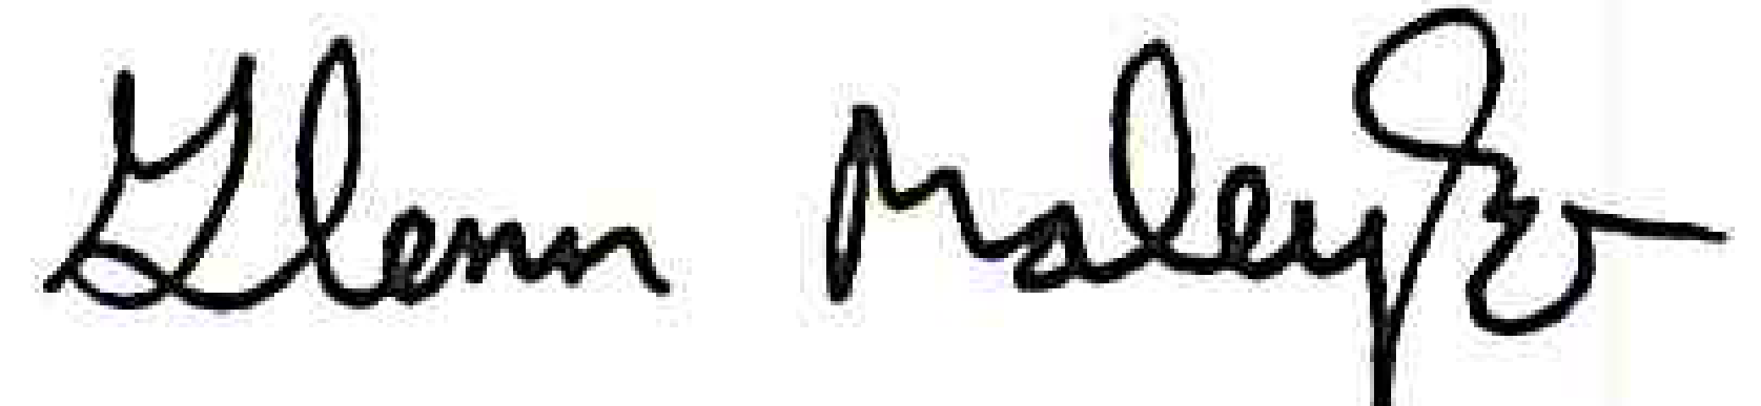

Glenn M. Maleyko, Ph.D.

Superintendent