Dearborn



Meemic Toler-Stemen Insurance Agency present's

Classroom Makeover Winner

Snow Elementary School

Wendy Shene

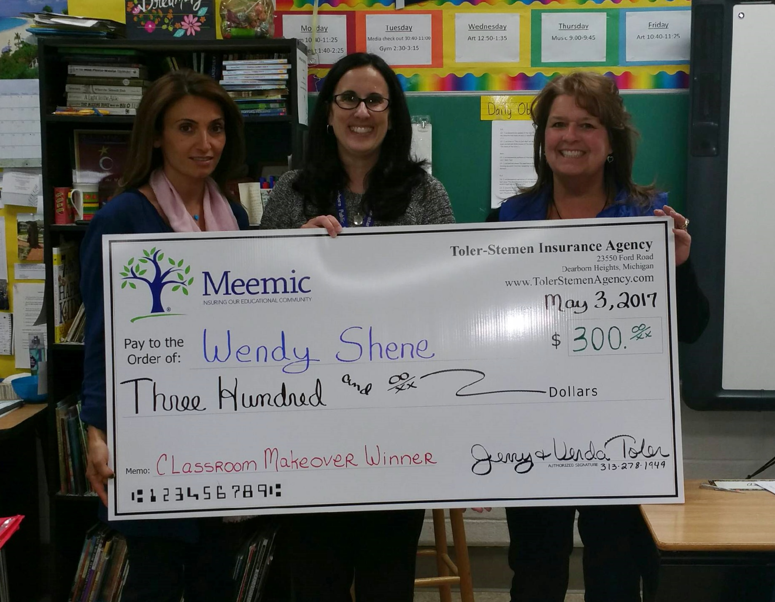

Amal Alcodray (Principal), Wendy Shene (Winning Teacher), Janet Toler-Stemen (Meemic Agent)

I would love to have the opportunity to make my classroom a more comfortable learning environment. At Snow we have tiled floors and students are expected to read on the floor around the room. I have purchased my own carpets and bean bags, but over time they have become very worn out. I would appreciate a new carpet area to be used for the gathering place during daily 5 and several new bean bag chairs for students to use around the room. These items would enhance the students learning environment and would be appreciated by all learners!

