**Multi Media**

**Classwork 5-14-18**

**Creating Another Mask using Fireworks**

**Today’s Objectives:**

By the end of the class period students should be able:

1. To create picture filled letters using the paste as mask function.
2. **Open a new Fireworks document**

**Dimensions:**

**W 1200**

**H 800**

**black background**

1. **Pick a topic, type in letters and choose a font. NOTE: Impact is one of the best fonts to use as it is a thick heavy font which will allow more room for pictures to fill.**
2. **Add images to the canvas to cover the letters. Once you have the images where you want them over the letters, you must change the layers to have the text on top of the images.**
3. **Once you have all the images where you want them;**

**Select all layers then, from the menu bar click on Modify>Mask>Group as Mask to see images fill the letters**

* **ADD inner bevel effect**
* **Change canvas color and size**

1. **For Extra Credit, create a two word mask**

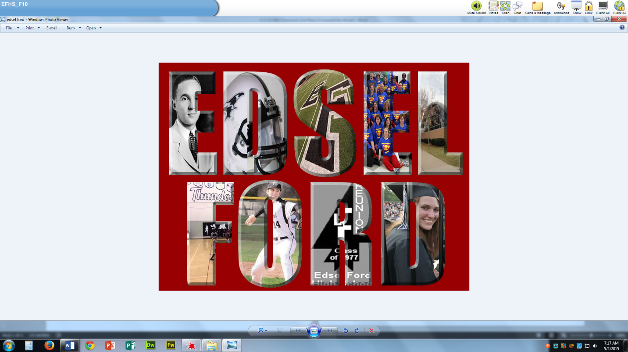

**Save as ### last name, first name-Mask2**

**Then save again as a JPEG and drop off only that version.**