**Multi**

**media**

**Class work**

**3-**

**-**

**08**

**-**

**18**

**Intro to Publisher**

**Templates**

**Invitation**

**Today’s Objectives:**

By the end of the

project

students should be able to

say

:

**1.**

***I CAN***

**e**

**xplain and understand what Microsoft Publisher is and what it can do**

**2.**

***I CAN***

**u**

**nderstand**

**what a template is and how to use it to create a new publication**

**3.**

***I CAN***

**understand how to modify text boxes and auto**

**-**

**fit font**

***1.***

***Open Microsoft***

***Publisher***

***-***

***click BUILT IN***

***2.***

***Click on***

***Quick Publications***

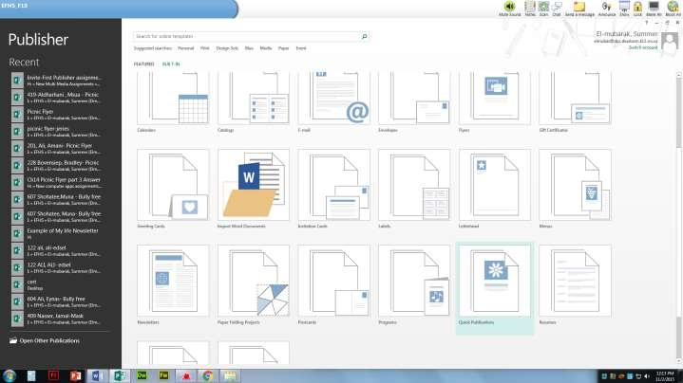

***3.***

***Find a design that you like***

***, click***

**CREATE**

4.

Create a

document with the following information:

a.

Announcement:

“Happy 16

th

Birthday”, “Congratulations” etc.

b.

Explain what you are celebrating in one sentence

.

c.

When:

d.

Where:

e.

Contact name and number

5.

Add an appropriate image

6.

Change the default colors of the backgroun

d

to a different theme so the

colors match the image you added and the theme of ‘your party’

7.

Save as: Last name,

first name

-

Invite

a.

Example Shaw

:

,

James

-

Invite

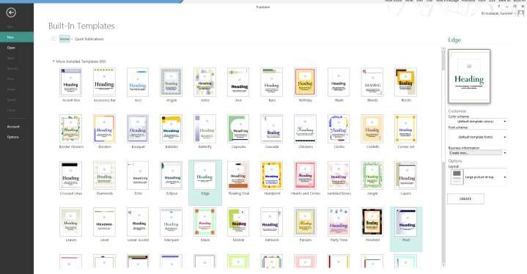

8

.

Then save again as a PDF

9

. DROP OFF

only the PDF version

WHEN COMPLETE

!

Do

not print!!!