**Multi Media Class work**

**3-12-18**

**Vacation Brochure**

**Today’s Objectives:**

By the end of the class period students should be able to:

1. ***I CAN* explain spacing on the brochure template**
2. ***I CAN* manipulate text boxes including deleting or adding additional boxes**
3. ***I CAN* remove or change default information**
4. ***I CAN* explain the concept of “White Space”**
5. Open Microsoft Publisher

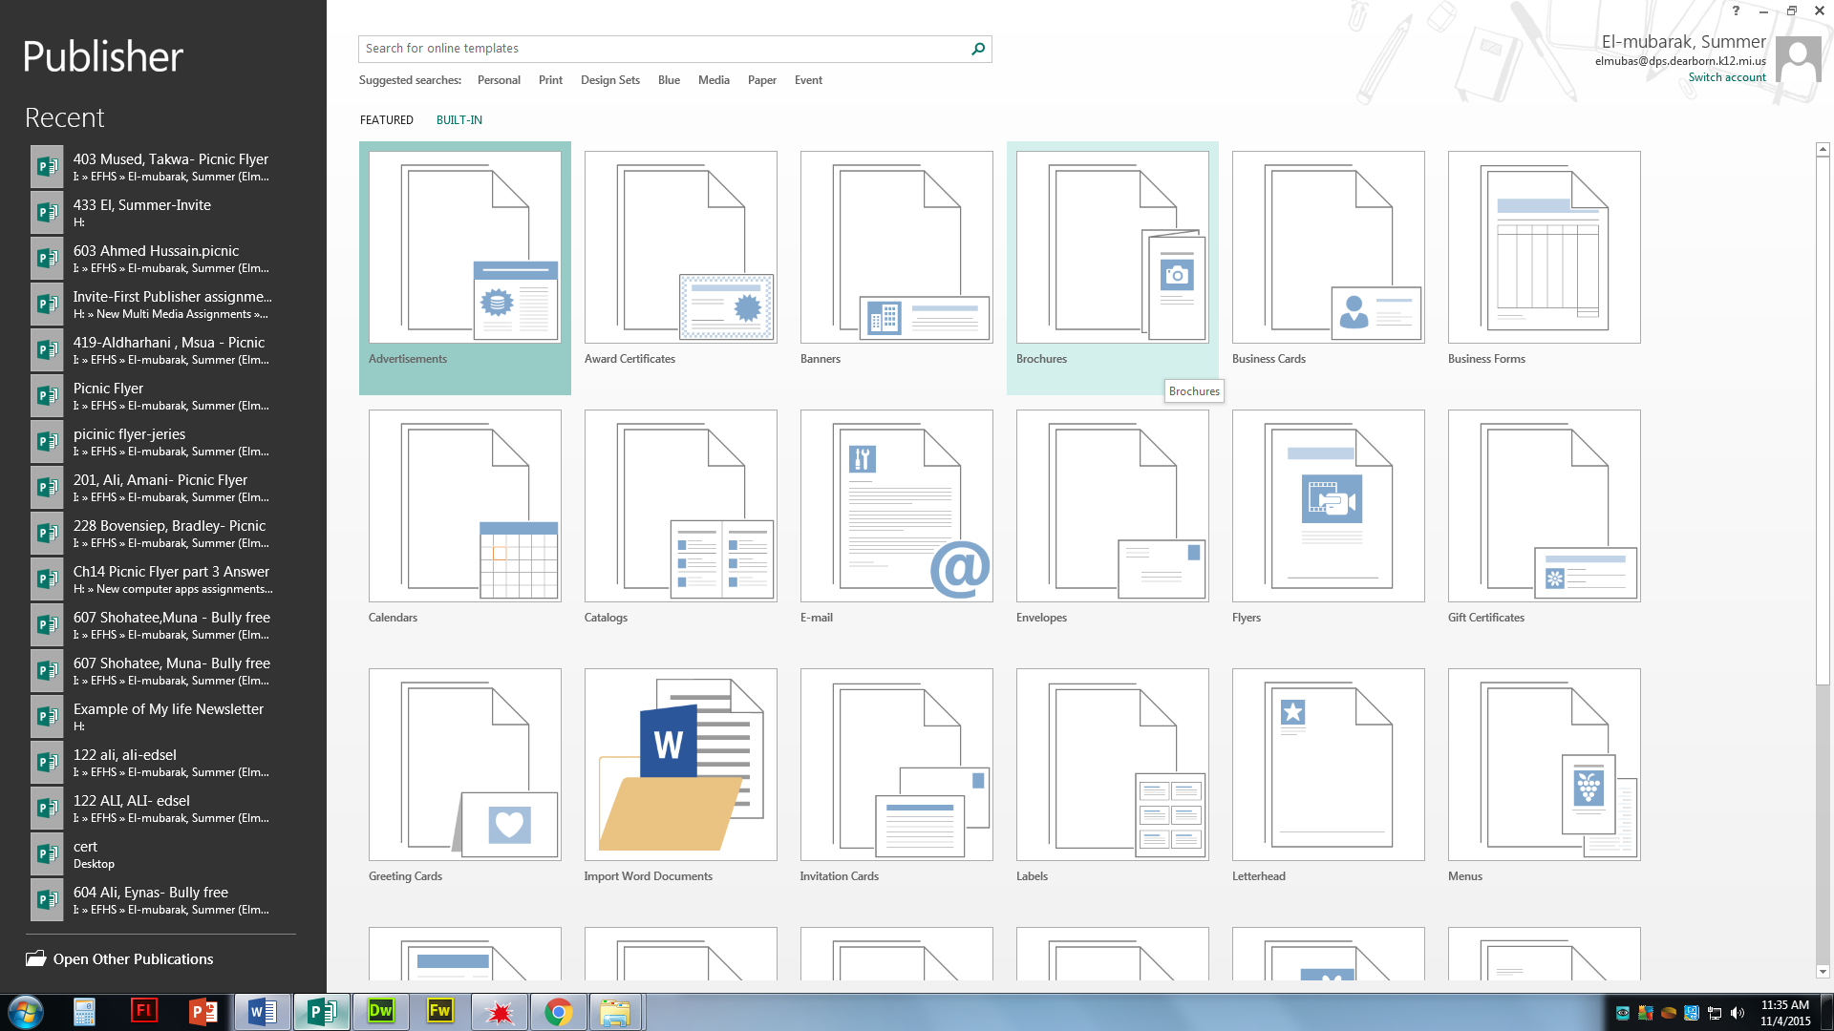

1. Click on Built in and then Brochures
2. Choose a Template style (must be Informational not Price List)

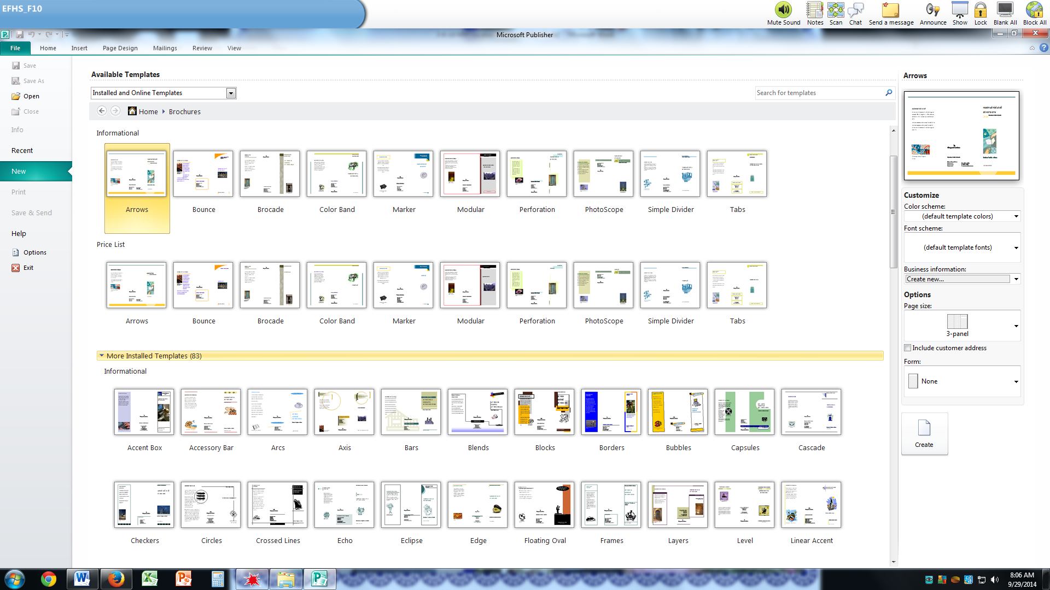

1. Create a Brochure about a vacation destination
   1. The brochure should contain all of the following information:
      1. Name of city or attraction on the cover
      2. Photo on the cover
      3. On the back panel heading, flap you should write a description of the city or attraction and why someone would want to visit there.
      4. On page two, you have three columns; each column should describe some tourist attractions and have photos.
      5. Find your information on the internet
2. You should do the research for this assignment before you start on the brochure.
3. Do not turn in until all aspects are complete; do not leave any of the areas on the template with the default information on them. You must fill in each section or delete whatever is not used.
4. Save as last name, first name-Vacation
   1. Example Doe, John-Vacation then save as a .PDF
5. Drop off only the .PDF version when complete

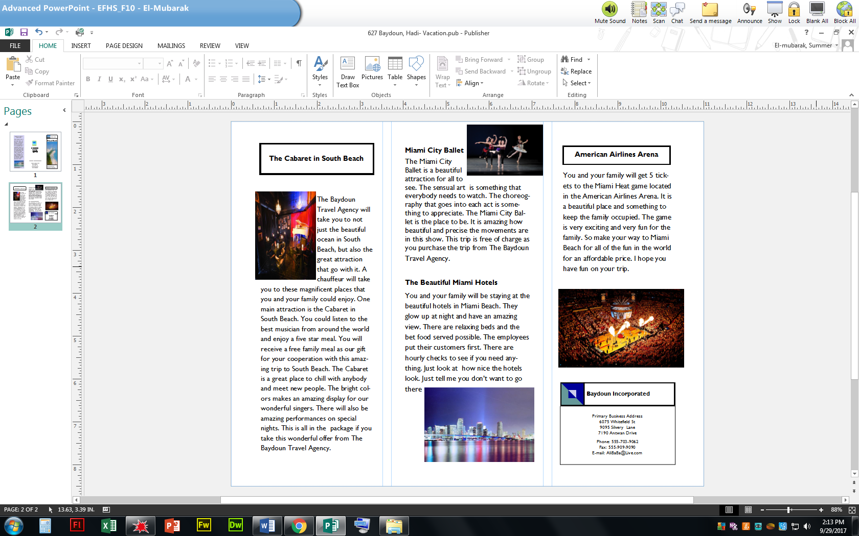

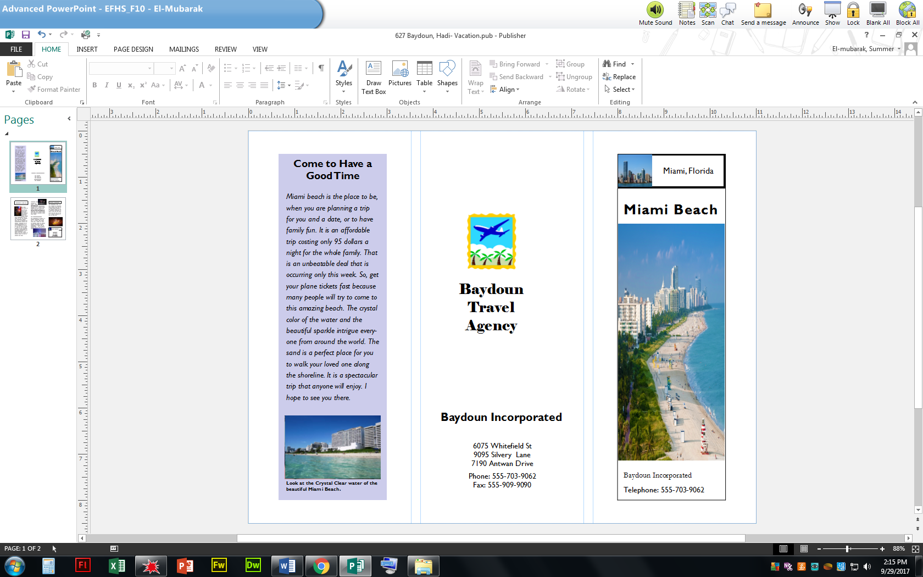

Page 1 Page 2