**Multi Media**

**Class Work**

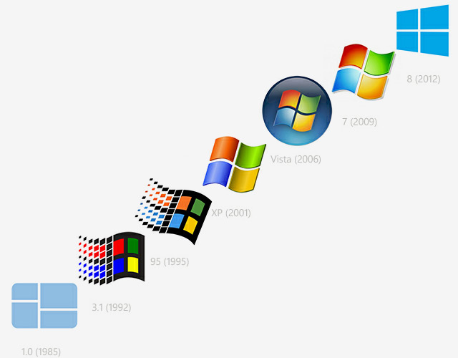**2-26-18**

**Objectives Tested:**

* **I can create an impactful PowerPoint**
* **I can add custom animation**
* ***I can add sound to one element on each slide***

**Brief History of Computers**

**PowerPoint Assignment #3**

1. Research the “history of computers”
   * Go to [**http://www.computerhistory.org/timeline/**](http://www.computerhistory.org/timeline/)
   * **http://www.computerhope.com/history/**
   * **http://www.datesandevents.org/events-timelines/07-computer-history-timeline.htm**
2. Find 10 important names, dates and events.
3. BEFORE YOU START YOUR PRESENTATION
   * You must write out the 10 dates you are going to use in chronological order (you must show me this document before you start the PowerPoint)
   * Make sure each date has a **person, an invention and three facts about the invention**
4. Create a PowerPoint Presentation using this information. PP must be 12 slides
5. 1st slide must be introduction-
   * Title of presentation (History of Computers) and your name date and hour and must include a *picture*
6. Next ten slides must be information slides
   * Must have name of person, date and what the important invention or event was.
   * Slides must be in chronological order
   * Each slide must contain a *picture*
   * Must contain animation to all features on each slide
   * Must contain sound on at least one feature on each slide
7. Last slide must be a conclusion. Add a picture!
   * (make at least 4 summary statements: What I’ve learned about computers)
8. Save as ### Last name, first name-Computers
   * Example 314 El-Mubarak, Summer-Computers

Example of Notes for your Timeline

Year 1966 PERSON Ralph Baer

Invention Pong is released

* + - designed a Ping-Pong game
    - for his Odyssey gaming console
    - the very first sports arcade video game

1. Year PERSON

Invention and 3 Facts about it

1. Year PERSON

Invention

1. Year PERSON

Invention

1. Year PERSON

Invention

1. Year PERSON

Invention

1. Year PERSON

Invention

1. Year PERSON

Invention

1. Year PERSON

Invention

1. Year PERSON

Invention

1. Year PERSON

Invention