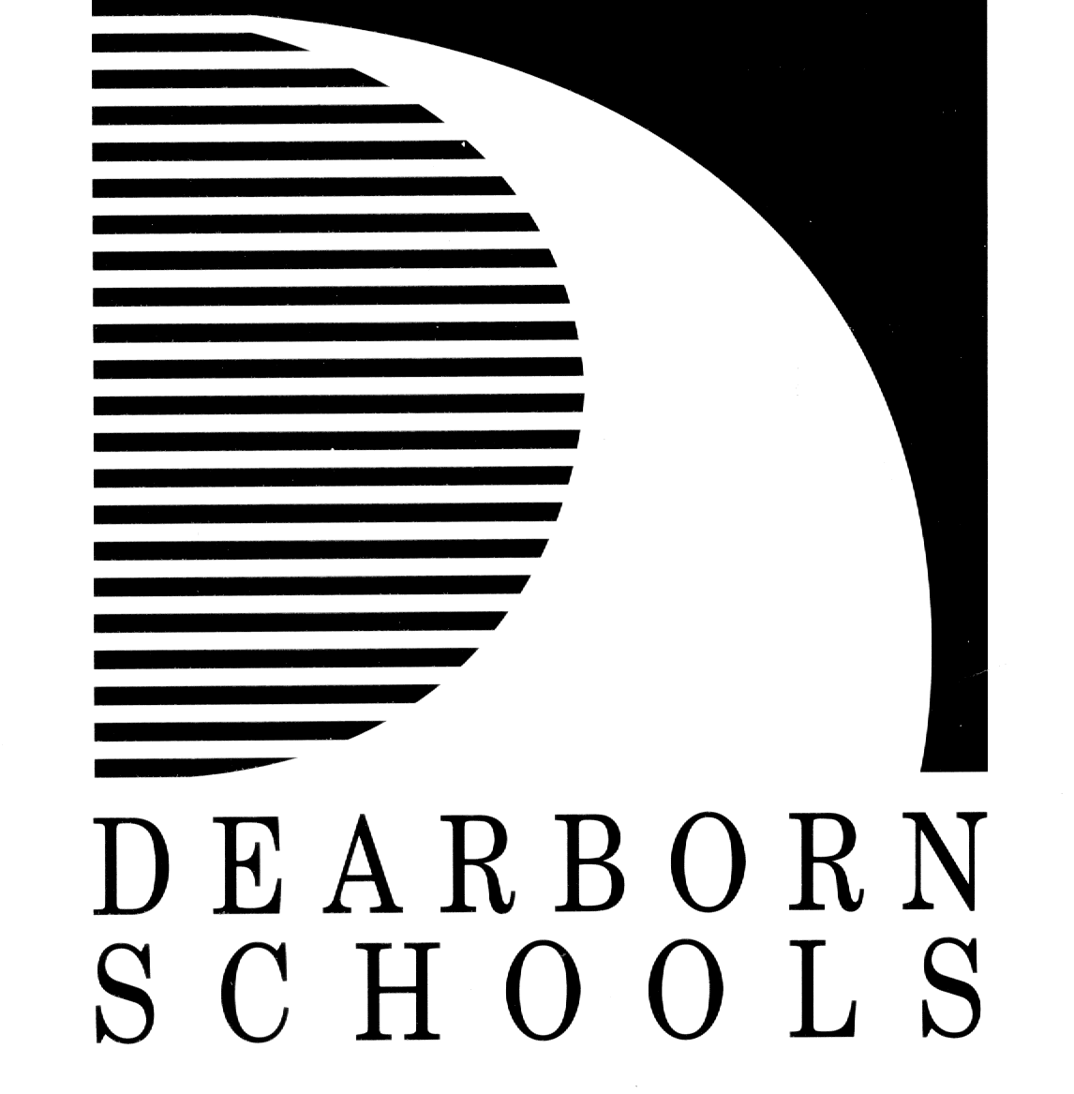

Dear Parents:

Please be aware that there is a student in your child’s classroom who has a potentially life threatening food and/or nut allergy. As a result, it is imperative that we all keep this in mind when planning any food activities for the children.

We are asking your help and cooperation to maintain a safe environment for all. Please do not send any classroom treats without first contacting your child’s teacher. Remember this serious allergy situation when sending any food to school with your child. Students are allowed to have peanuts/nut in the lunchroom and allergy students will have a separate table if needed. Our goal is to keep any products out of the classroom that could cause a serious reaction.

https://ci6.googleusercontent.com/proxy/RnNZfQn2o2xpggJQqefCOervMbPIci5mujDPJnvl43kv6Rtxjyh5gHN_JKVzeU-aaGz3pePFgxfoAAtZJZNx8mveVTc-11j98EfuAJVcumUenA=s0-d-e1-ft#https://ssl.gstatic.com/ui/v1/icons/mail/images/cleardot.gifIf you have any questions or would like clarification of the need to adapt an event to this situation, you may contact your school and ask to speak with the school nurse.

Thank you for your help and understanding in providing a safe environment for all of our students.

Sincerely,

*Dearborn Public Schools School Nurses*