Name: Date: Hour:
Window Notes: The Crucible
Act 2 (part 1) Pg.
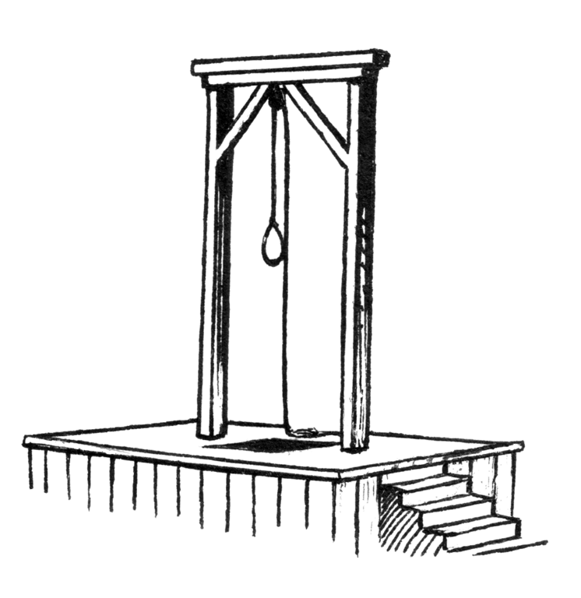
Directions: Fill out each section to the best of your ability as you are reading. You may consider attaching a separate sheet for vocabulary, or if
you do not have enough room for the other sections. Please read this section with your table and pick roles to read aloud. **Follow the
directions for assigning roles and completing all of the necessary tasks on the “Group Reading Activity” sheets.

Summary: Use one of the handmade thinking options to craft a summary of the events from page ___ to page _____. You must also include a 25-word summary of the text.
Reaction and Prediction: Write a two sentence response to what occurred. Write a one sentence prediction for what will happen in Part 2 of Act 2 to be confirmed or denied by the text.
Questions: Answer all of the questions given in complete sentences.  Questions Continued | - What happens to the people that are accused of witchcraft and do not confess? How does this create a shift in power in the town of Salem? Use text evidence to support your response.  - What does Mary Warren give to Elizabeth? In your opinion, why does she give it to her? Do you think Mary’s intentions are good? Explain your reasoning.  - According to Mary Warren, why was Elizabeth’s name brought up in court?  - How does Mary Warren attempt to gain back her freedoms and liberties from her employers, the Proctors? What does she say to John in response him threatening to beat her? Who has the power in this relationship and how do you know?
Author’s Craft:
Provide two examples of a motif present in the text. You must use textual evidence to identify the literary device and then provide a justification/explanation. **Note: A motif is a recurring theme or literary device used to further develop major themes.
Handmade Thinking Options
