**enVision Math AGA Digital Access**

Dear Parent or Guardian,

Our class is enrolled in a new online curriculum program for instruction and student assignments. This program is called enVision AGA for Algebra 2 and it is accessed online using Realize. Realize offers educational opportunities including helpful tools for online student work and tracking student progress. Below are the directions to get access from home.

Get Started

1. Go to Dearborn Public Schools website: <https://dearbornschools.org/>
2. Click on Student Portal
3. Click on Google Drive/Docs Login

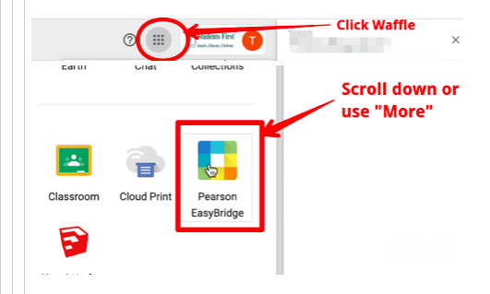

1. Click on Pearson EasyBridge and it will take you to the student’s course.