Mrs.Sbeity and Miss Yandura’s Semester Challenge

There are officially 18 more weeks of 1st semester! We challenge YOU to increase your grade by at least ONE WHOLE letter grade. If your letter grade cannot go any higher (A), then your challenge is not to decrease your percentage. We know you have what it takes, but do you know?
If the WHOLE class is able to complete this goal, you will win the prize that is decided upon in class.
Prize: ________________________________________________________________________
---------------------------------------------------------------------------------------------------------------------------------------------------------------------------------------------------------
Directions: Use this grid to graph your weekly progress. You will turn in this packet on the LAST DAY of each CARD MARKING for SUMMATIVE CREDIT.
______________________________’s
Weekly Grade/Progress Report
P
e
r
c
e
n
t
a
g
e
9/23 9/30 10/7 10/14 10/21 10/28 11/4 11/11 11/18 11/25 12/2 12/9 12/16 1/6 1/13 1/21
Week

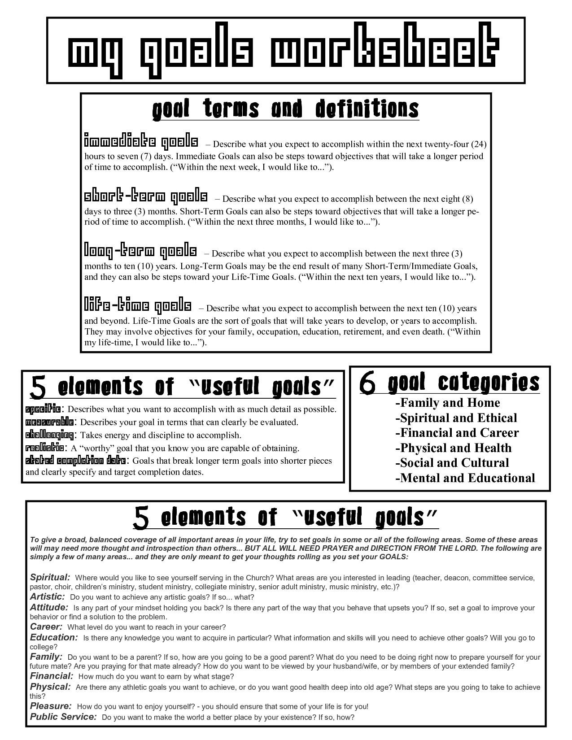

Card-Marking 3 Goal and Weekly Tasks (6 Weeks)
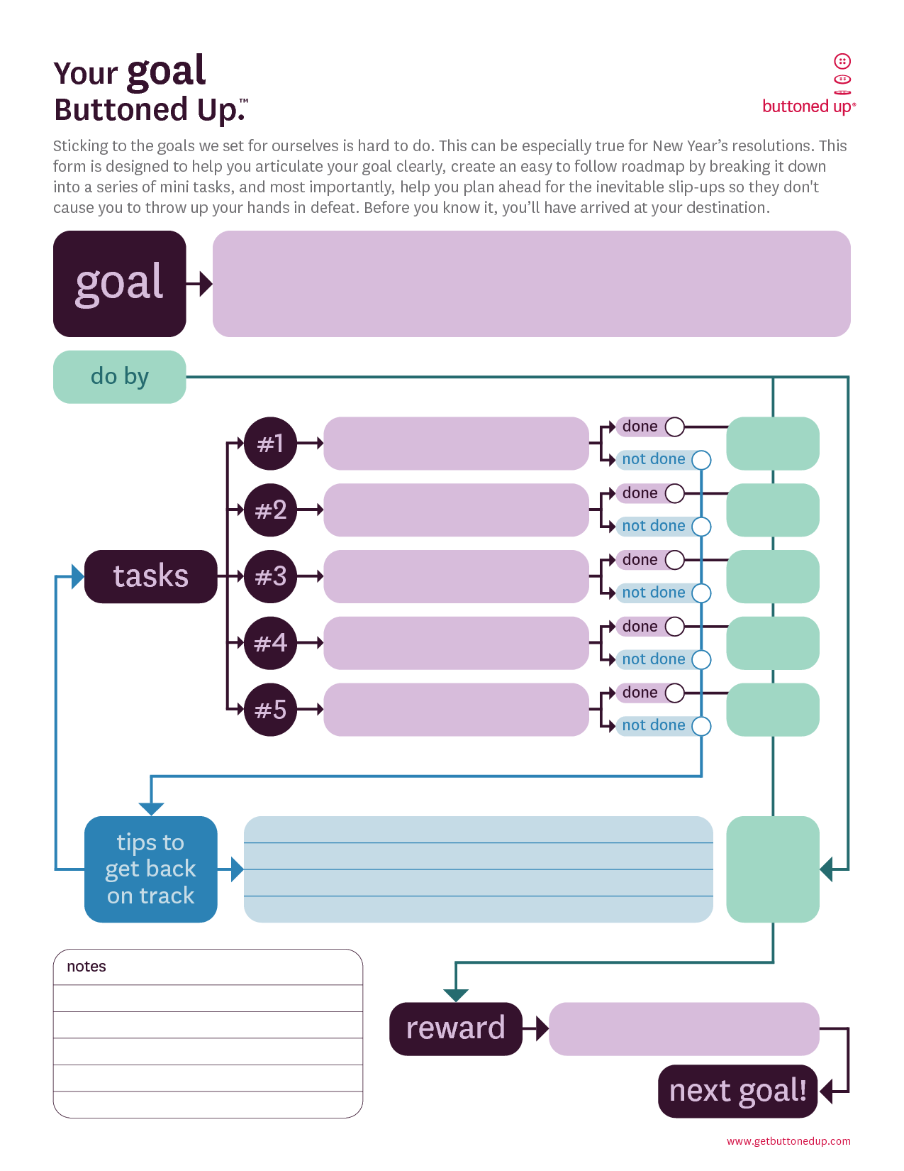
Ends January 25, 2014

Weekly

Card-Marking 1: Goals and Weekly Tasks (3 Weeks)

Weekly

Card-Marking 2 Goal and Weekly Tasks (7 Weeks)
Ends November 26, 2013

Weekly
Weekly

