Salina K-5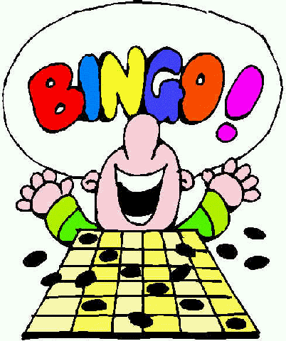

Bingo for Books

Date: March 14, 2019

Time: 3:30-4:30

Place: Salina Elementary

***Admission: $1 per child (2 game boards and 1 raffle ticket)***

**There will be Raffle prizes! Additional Raffle Tickets 25 cents!**

**Bingo Winners will take home books!**

**PTA will also be hosting a Bake Sale!**

Salina K-5

Bingo For Books

Date: March 14, 2019

Time: 3:30-4:30

Place: Salina Elementary

***Admission: $1 per child (2 game boards and 1 raffle ticket)***

**There will be Raffle prizes! Additional Raffle Tickets 25 cents!**

**Bingo Winners will take home books!**

**PTA will also be hosting a Bake Sale!**

Salina K-5

Bingo for Books

Date: March 14, 2019

Time: 3:30-4:30

Place: Salina Elementary



***Admission: $1 per child (2 game boards and 1 raffle ticket)***

**There will be Raffle prizes! Additional Raffle Tickets 25 cents!**

**Bingo Winners will take home books!**

**PFSO will also be hosting a Pizza Sale!**