**Waves through a Vacuum (Bell Jar)**

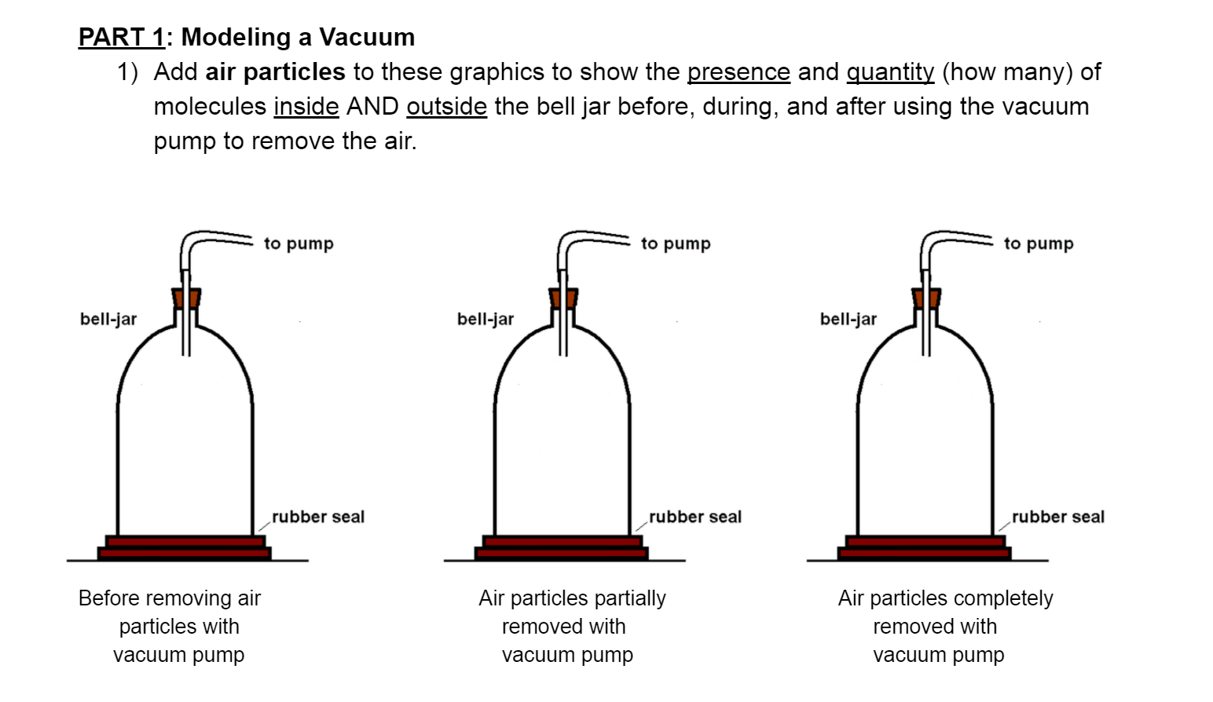

**Parts 2 (Buzzer) & 3 (Beeps):** Copy, paste, and observe the following YouTube videos closely by taking notes in your ISN.

<https://www.youtube.com/watch?v=hIOqX4uJtYY>

<https://www.youtube.com/watch?v=fxLY1SGXV_E>

**Create a trifold as shown**

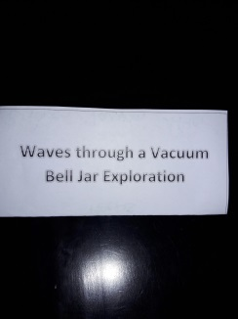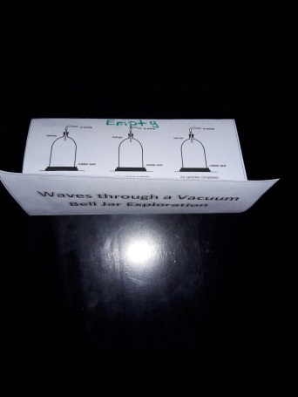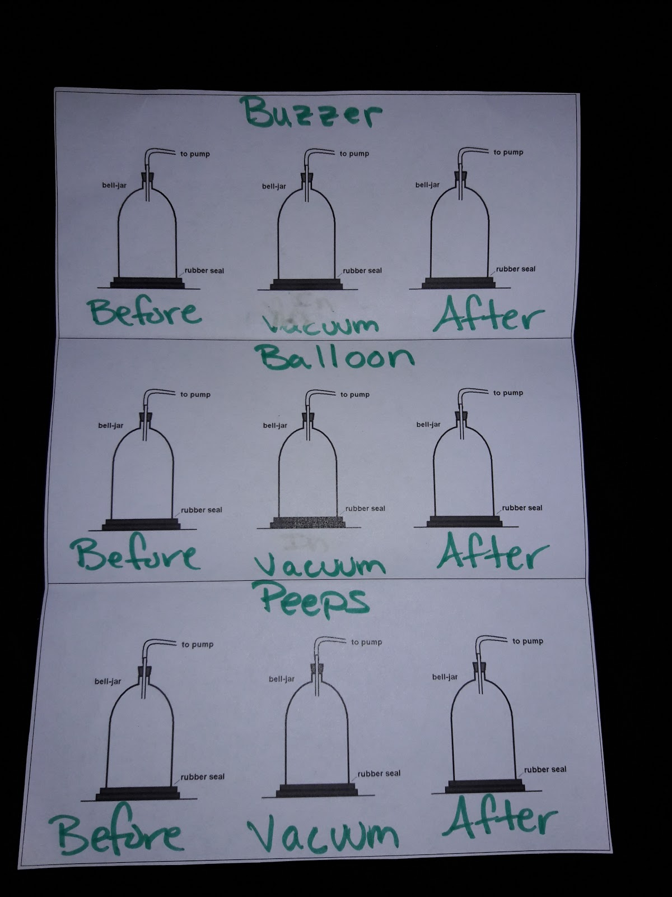

**Study the following videos on 3 types of waves:**

<https://www.youtube.com/watch?v=-n1d1rycvj4&feature=youtu.be> (Standing wave)

<https://www.youtube.com/watch?v=ubRlaCCQfDk&feature=youtu.be> (longitudinal wave)

<https://www.youtube.com/watch?v=1QhOjTaQaGE> (Transverse & Compression waves)