**ORBITING THE SUN**

**Planetary Physical Data**

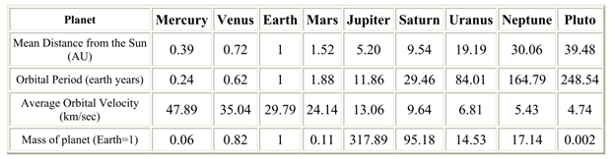

A **trend** is a pattern of gradual change in something.

1. I notice the **mean distance from the sun** increases from left to right.